 |  |  | 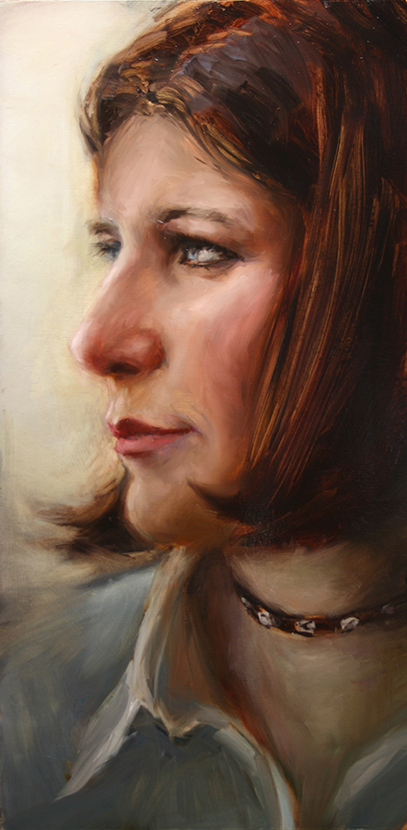 |  |  | Andi Campognone  40 x 20 in.  oil on canvas  $7,000.
 | 2. |  | 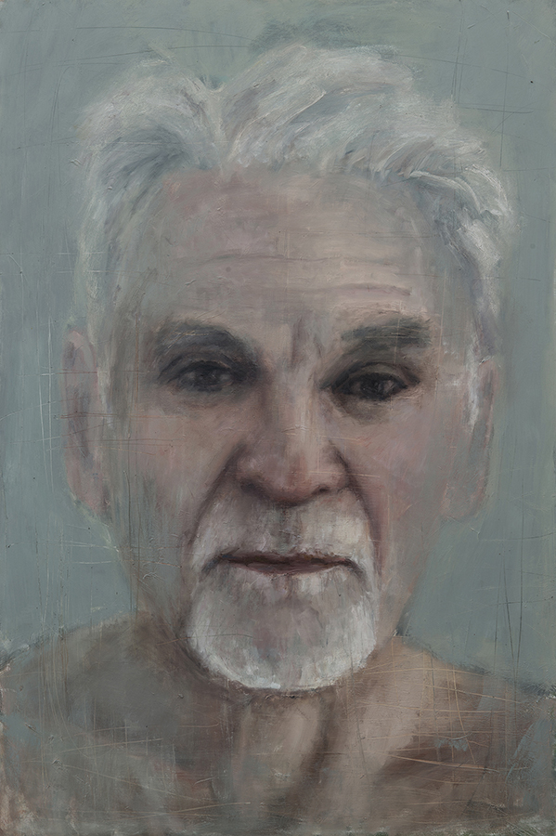 |  |  | Don Bachardy  60 x 40 in.  oil on canvas  $16,000.  .
 | 3. |  | 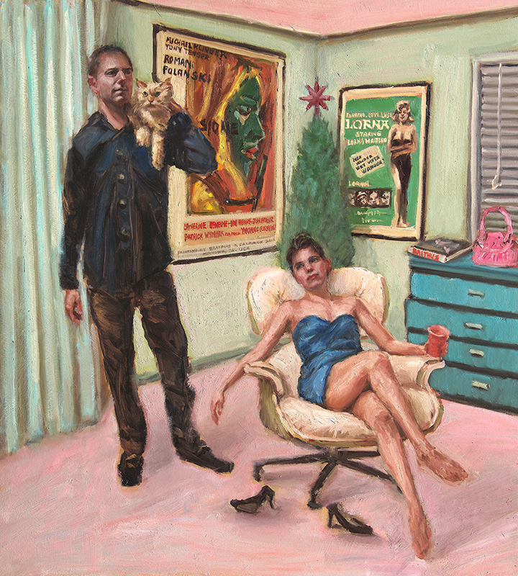 |  |  | Pink Purse  45 x 40 in.  oil on canvas  $18,000.
 | 4. |  | 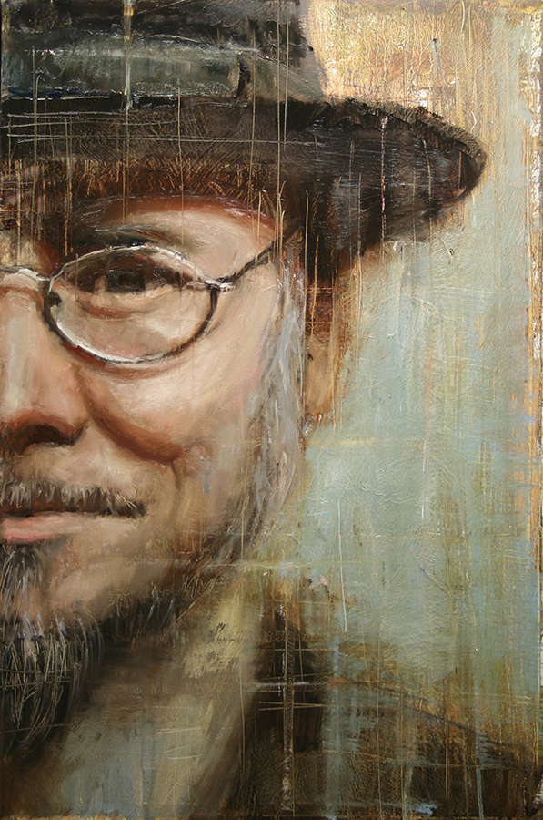 |  |  | Mark Ryden  30 x 20 in.  oil on canvas  $6,000.
 | 5. |  | 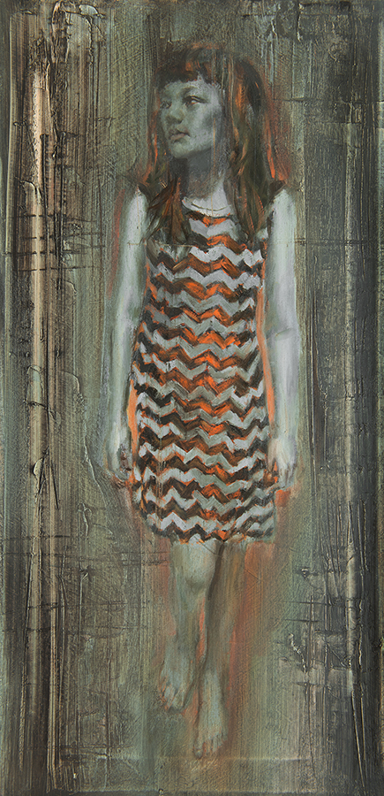 |  |  | Clare #11  30 x 15 in.  oil on canvas  $5,500.
 | 6. |  | 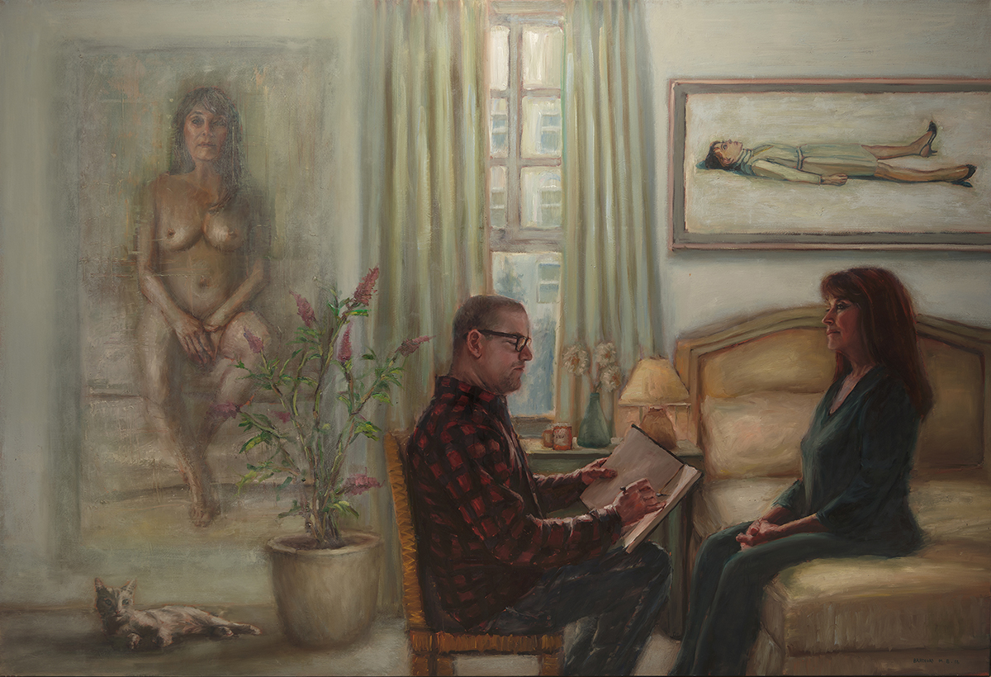 |  |  | Triple Twinka  72 x 105 in.  oil on canvas  $45,000.
7. |  | 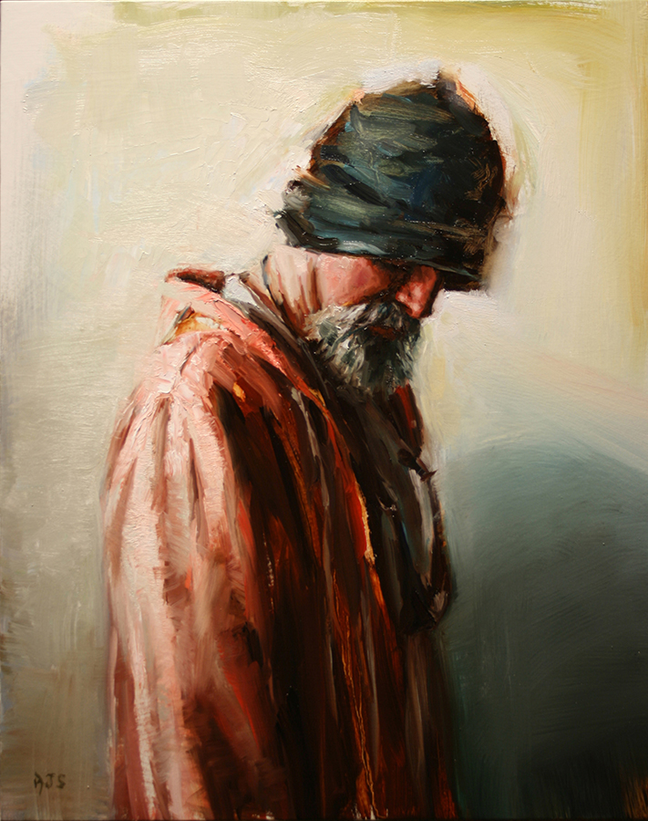 |  |  |  |  | William Wray  20 x 16in.  oil on canvas  $4,000.
8. |  | 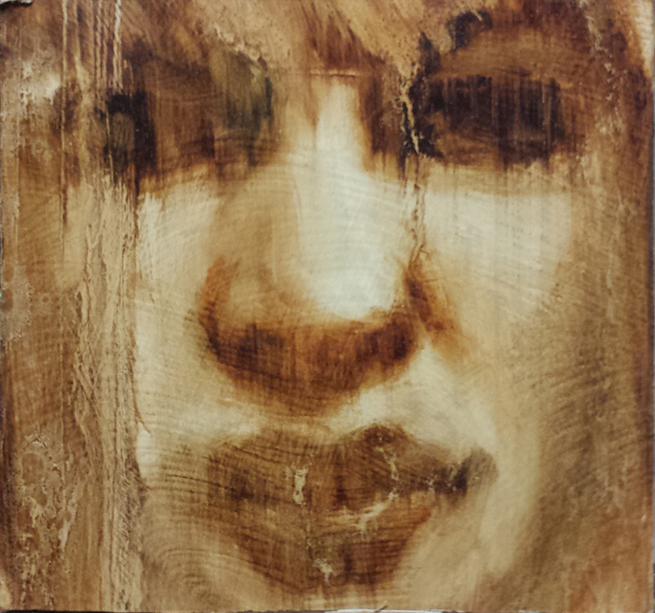 |  |  |  |  | Kelly Berg  5 x 5 in.  oil on panel  $1,800.
9. |  | 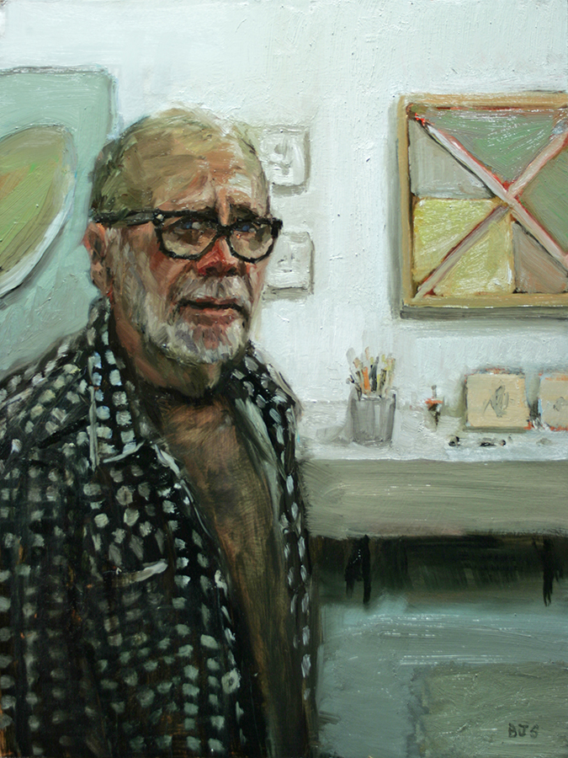 |  |  |  |  | Tony DeLap  24 x 18 in.  oil on canvas  $4,000.
10. |  | 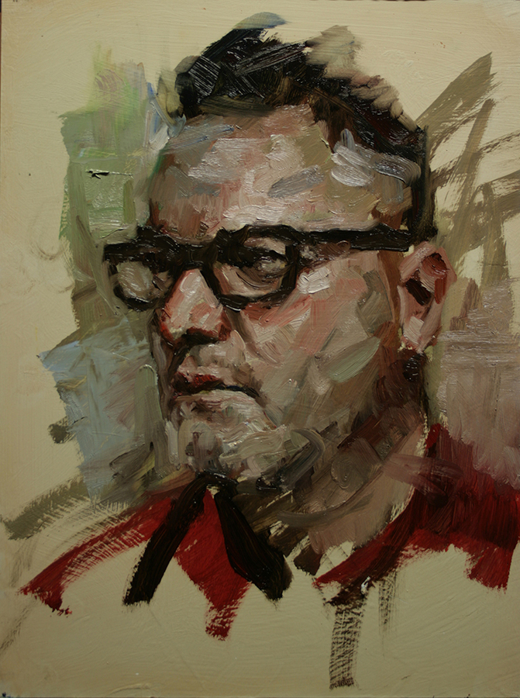 |  |  |  |  | Self Portrait 2016  16 x 12 in.  oil on panel  $2,800.
11. |  | 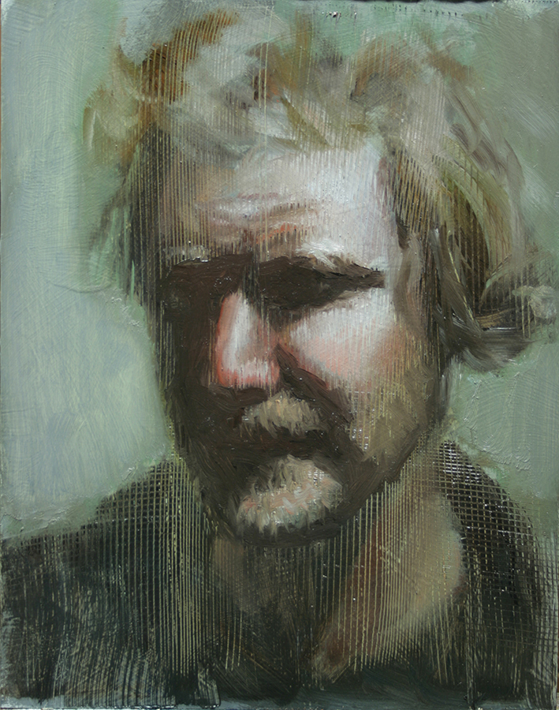 |  |  |  |  | Jeffrey Gillette  14 x 11in.  oil on panel  $2,500.
12. |  | 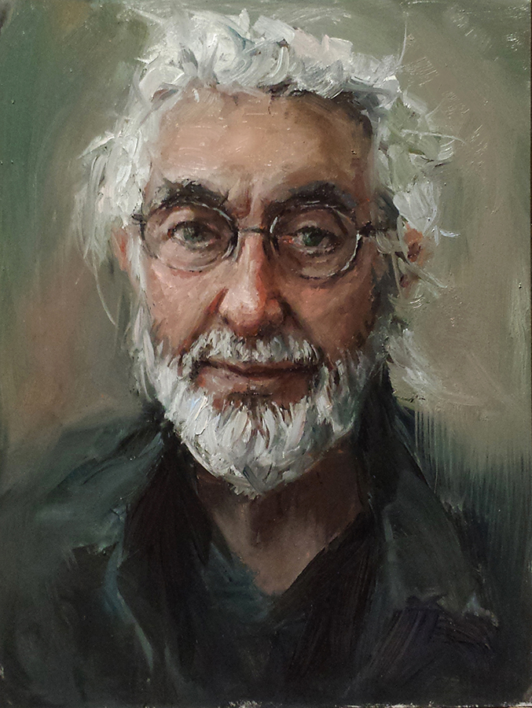 |  |  |  |  | . Roland Reiss  16 x 12 in.  oil on panel  $3,200.

13. | 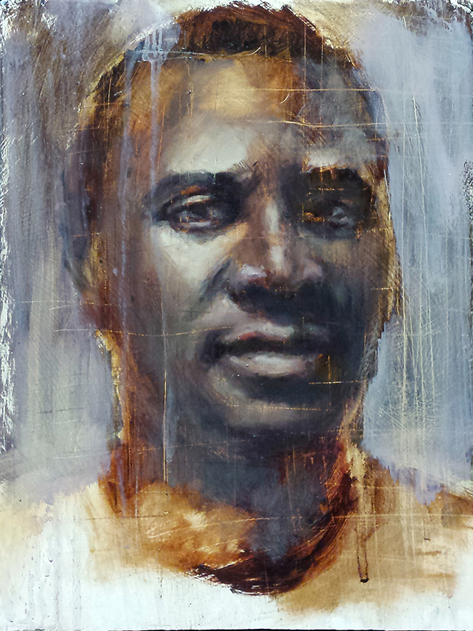 |  | Tajudeen Aiyeloja  12 x 9 in.  oil on canvas  $2,400.
14. | 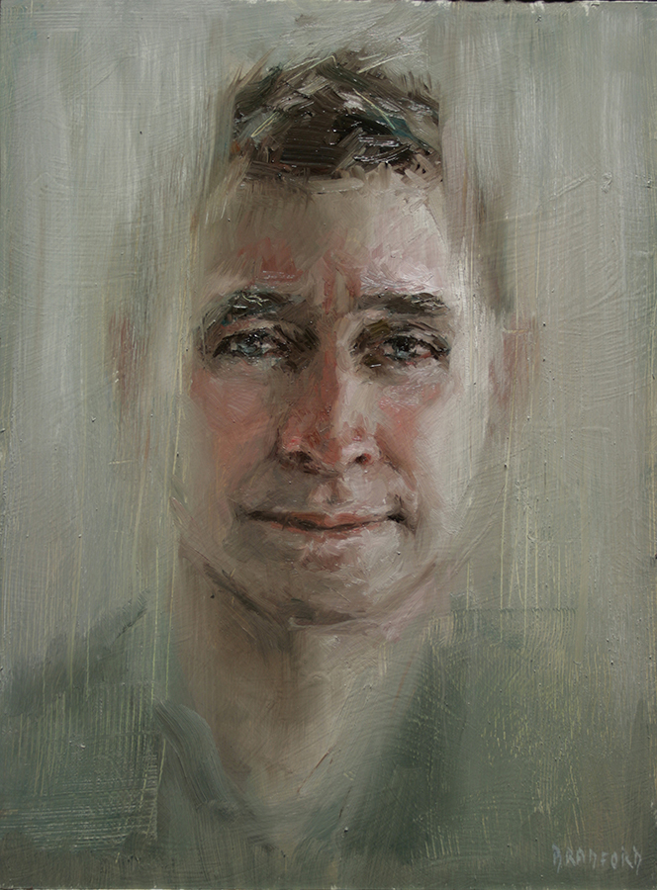 |  | Chris Gwaltney  16 x 12 in.  oil on canvas  $2,800.
.  15. | 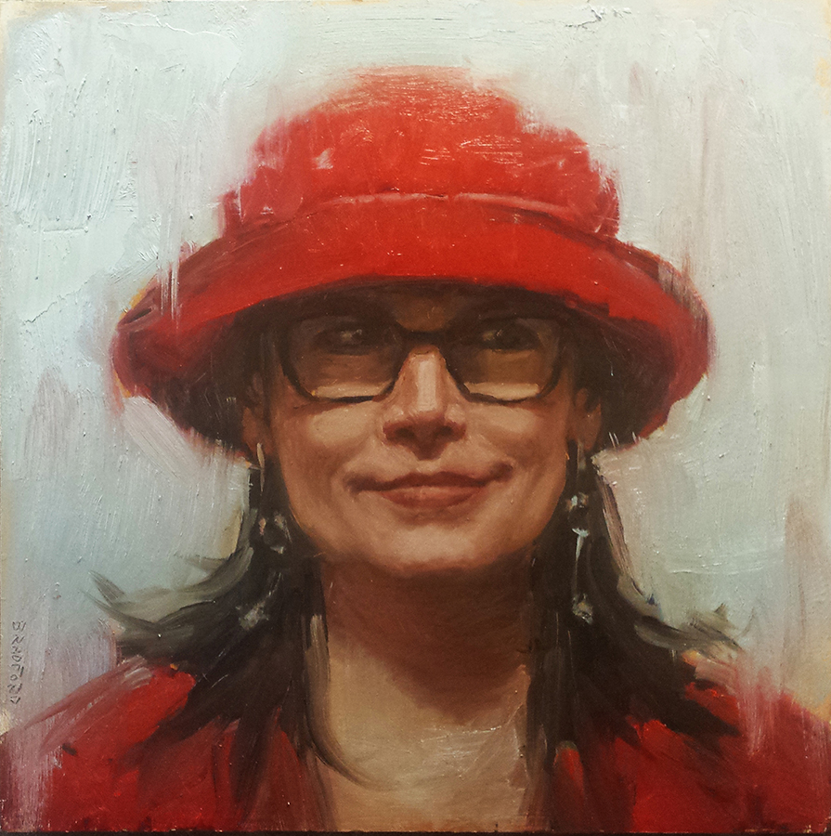 |  | Leigh Salgado  20 x 20 in.  oil on panel  $3,500.
16. | 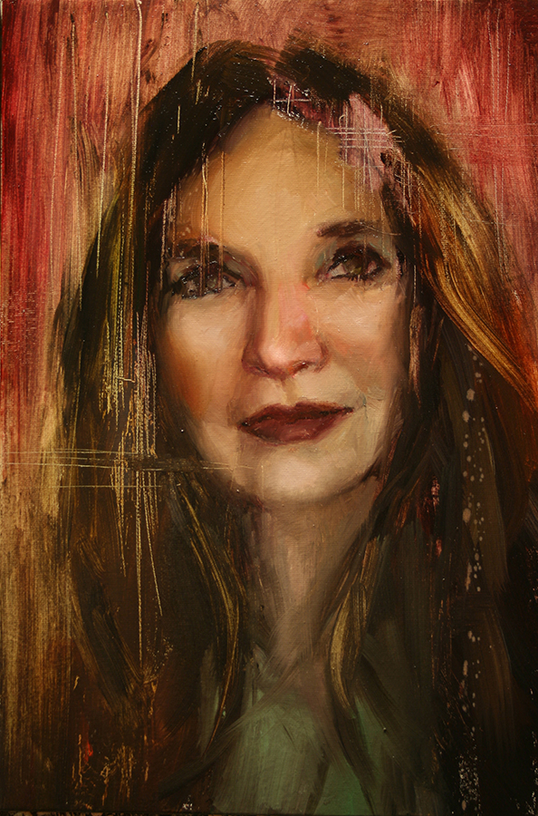 |  | Lita Albuquerque  15 x 10 in.  oil on canvas  $2,500.
17. | 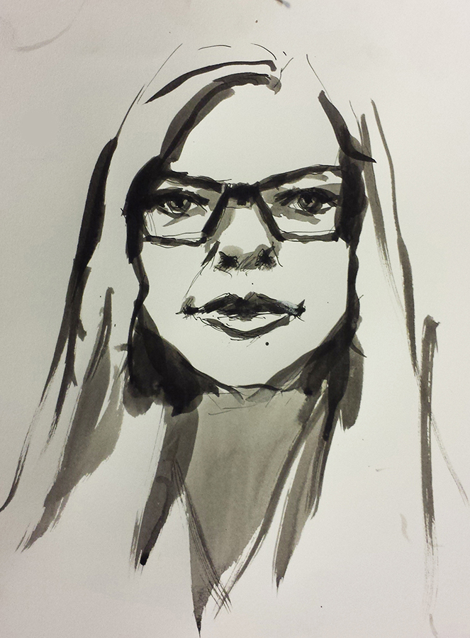 |  | Shana Nys Dambrot  14 x 11in.  india ink on watercolor paper  $1,500.
18. | 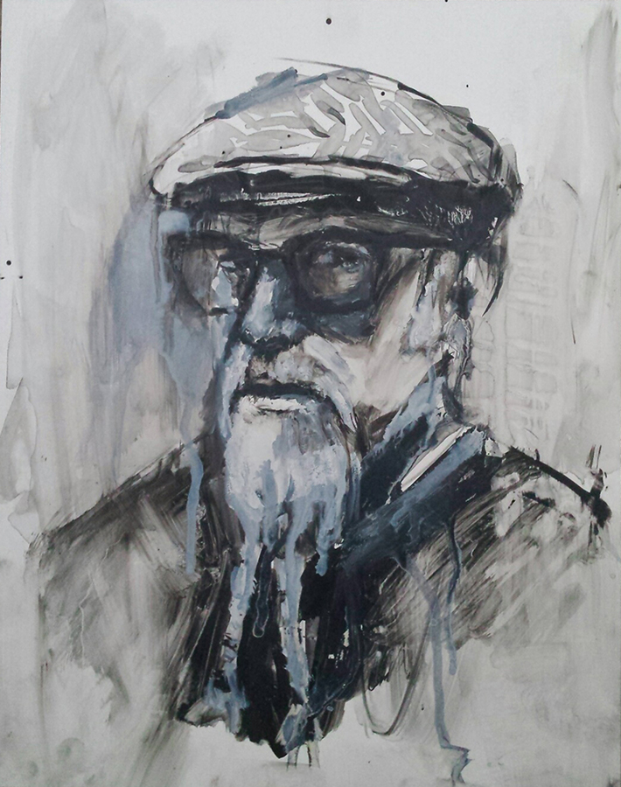 |  | Steve Radosevich  14 x 11 in.  india ink & gouache on Yupo  $1,500.
19. | 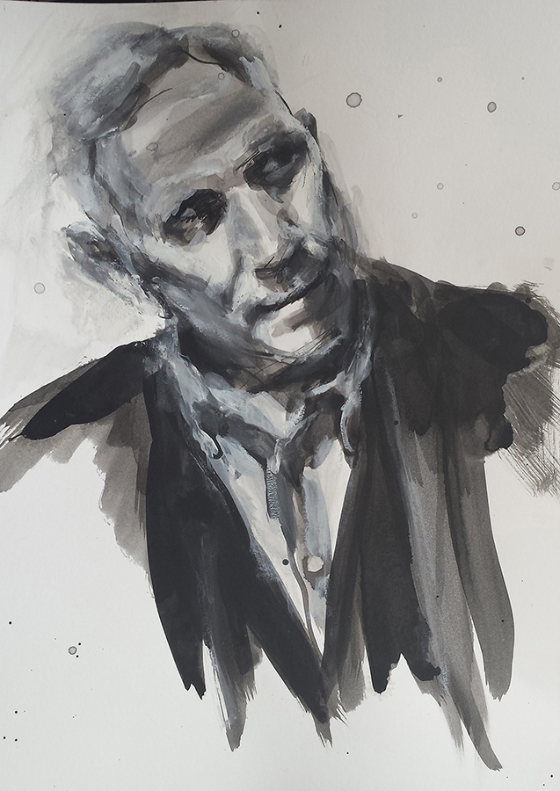 |  | Kenton Nelson  14 x 11 in.  india ink & gouache on watercolor paper  $1,500.

BR. | 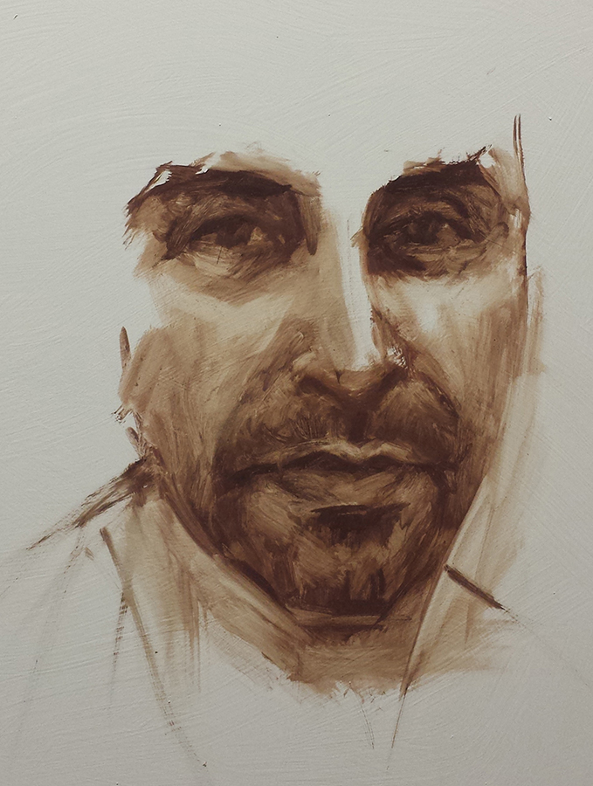 |  | John Scane  16 x 12 in.  oil on panel  $2,500.
BR. | 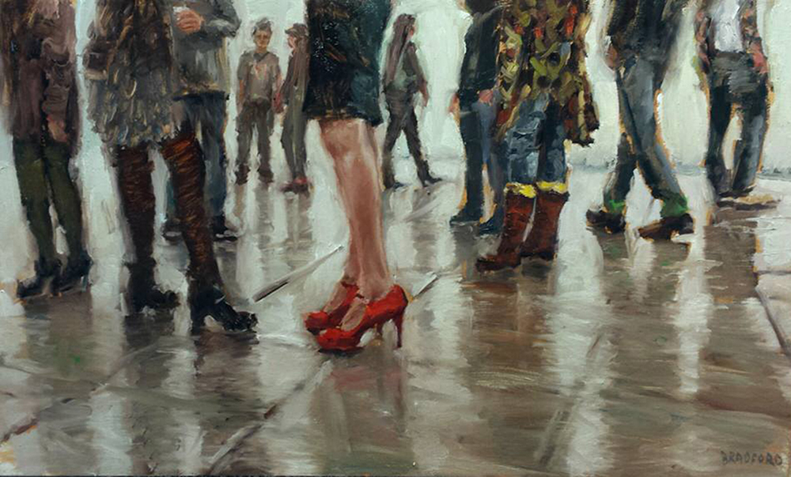 |  | Red Shoes  15 x 25 in.  oil on canvas  3,500.
BR.  BBR  BR. | 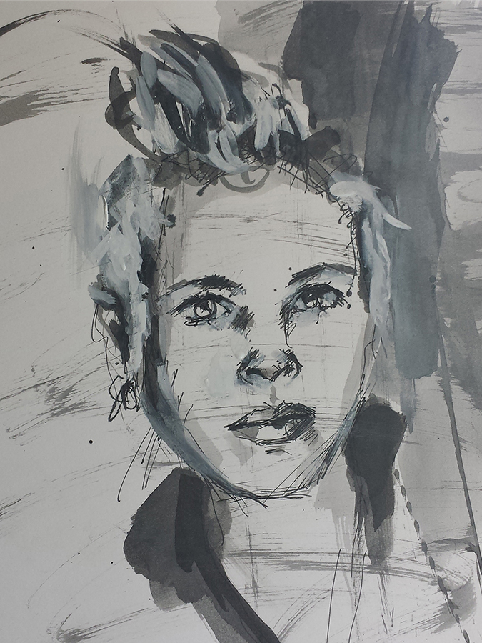 |  | Jennifer Celio  12 x 9 in.  india ink & gouache on watercolor paper  $1,400.
BR. | 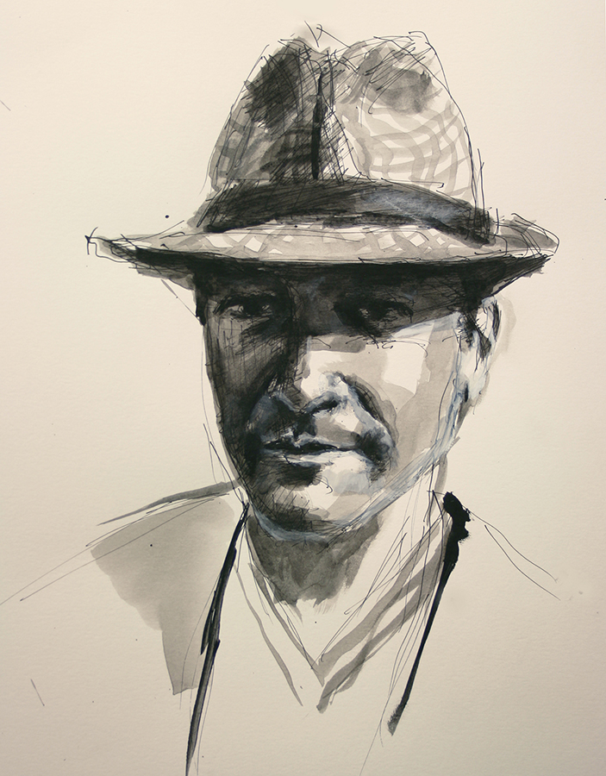 |  | Adam Stone  14 x 11 in.  india ink & gouache on watercolor paper  $1,500.
BR. | 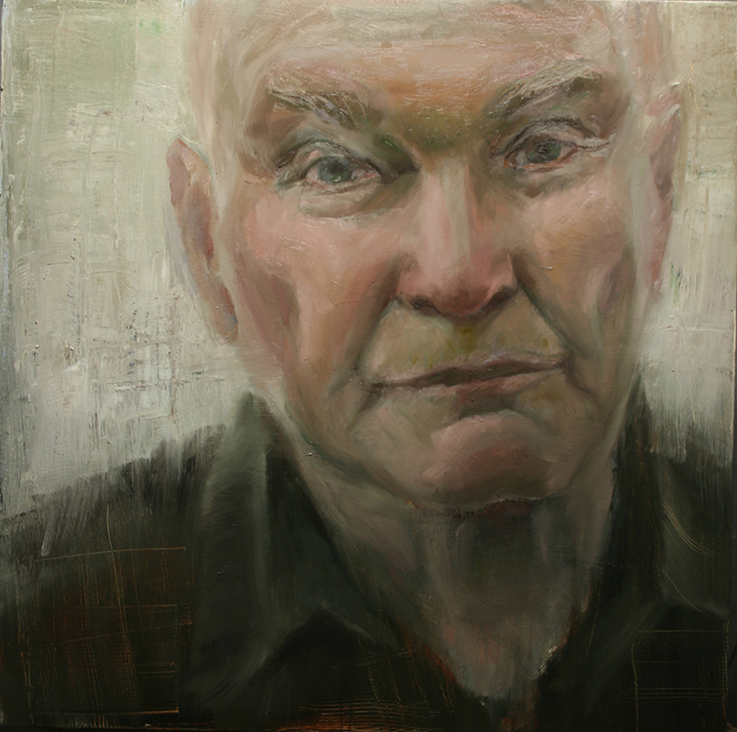 |  | Lou Swenson  36 x 36 in.  oil on canvas  $8,000.

