Ana Rodriguez – Abominable Gift Baskets
Nano Rubio – Fast & Hard
 |  | 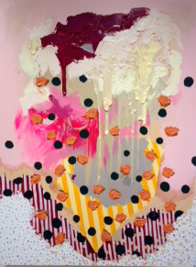 |  |  | Ana Rodriguez  Untitled1  oil, acrylic on canvas  48 x 36 in.  $2500.
 | 2. | 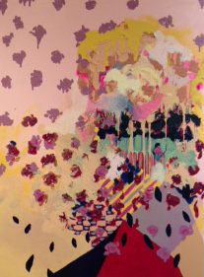 |  |  | Ana Rodriguez  Untitled 2  oil, acrylic on canvas  48 x 36 in.  $1350.  .
 | 3. | 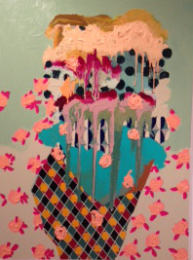 |  |  | Ana Rodriguez  Untitled 3  oil, acrylic on canvas  48 x 36 in.  $2500.  .
 | 4. | 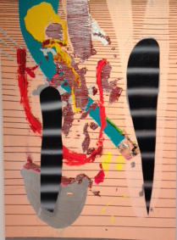 |  |  | Nano Rubio  Watcher 1  acrylic on canvas  46 x 32 in.  $2200.
 | 5. | 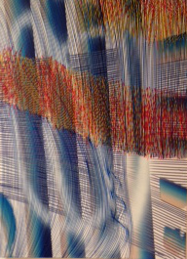 |  |  | Nano Rubio  Salor  acrylic on canvas  40 x 30 in.  $1600.
 | 6. | 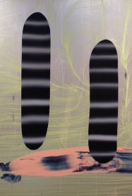 |  |  | Nano Rubio  Watcher 3  acrylic on canvas  46 x 32 in.  $2200.
7. |  | 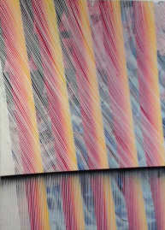 |  |  |  | Nano Rubio  Sunbeam  acrylic on canvas  40 x 30 in.  $1600.  .
8. |  | 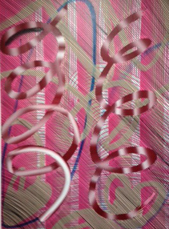 |  |  |  | Nano Rubio  Skeletor  acrylic on canvas  40 x 30 in.  $1600.  .
9. |  | 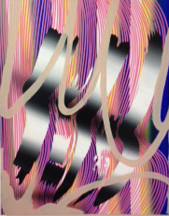 |  |  |  | Nano Rubio  Saturation  acrylic on canvas  30 x 24 in.  $800.
10. |  | 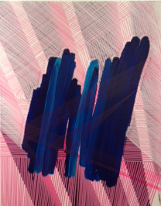 |  |  |  | Nano Rubio  Scrub  acrylic on canvas  30 x 24 in.  $800.
11. |  | 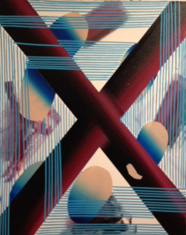 |  |  |  | Nano Rubio  Satellite  acrylic on canvas  46 x 32 in.  $800.  .
12. |  | 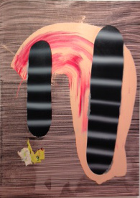 |  |  |  | Nano Rubio  Watcher 2  acrylic on canvas  30 x 24 in.  $1600.  .

13. | 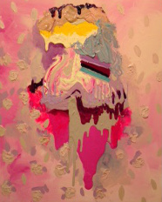 |  | Ana Rodriguez  Untitled 4  oil, acrylic on canvas  30 x 24 in.  $1350.
BR. | 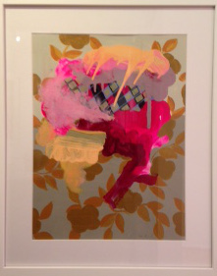 |  | Ana Rodriguez  Untitled 5  oil, acrylic on paper  21.5 x 17.5 in. framed  $750.
.  BR. | 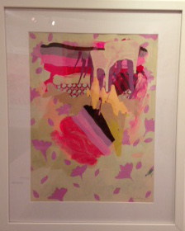 |  | Ana Rodriguez  Untitled 6  oil, acrylic on paper  21.5 x 17.5 in. framed  $750.
BR. | 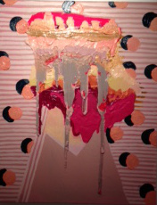 |  | Ana Rodriguez  Untitled 7  oil, acrylic on canvas  30 x 24 in.  $1350.
BR. | 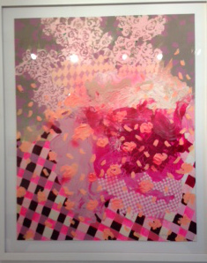 |  | Ana Rodriguez  Untitled 8  Acrylic on paper, framed  47" x 39"  $1,595.
BR. | 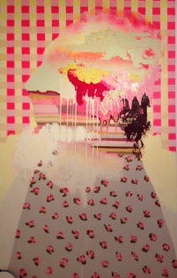 |  | Ana Rodriguez  Untitled, 2015  Acrylic, oil on canvas  78" x 48"  $3,000.
19. | 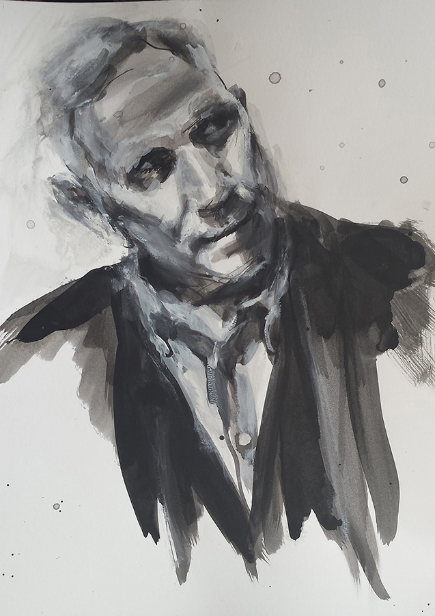 |  | Kenton Nelson  14 x 11 in.  india ink & gouache on watercolor paper  $1,500.

BR. | 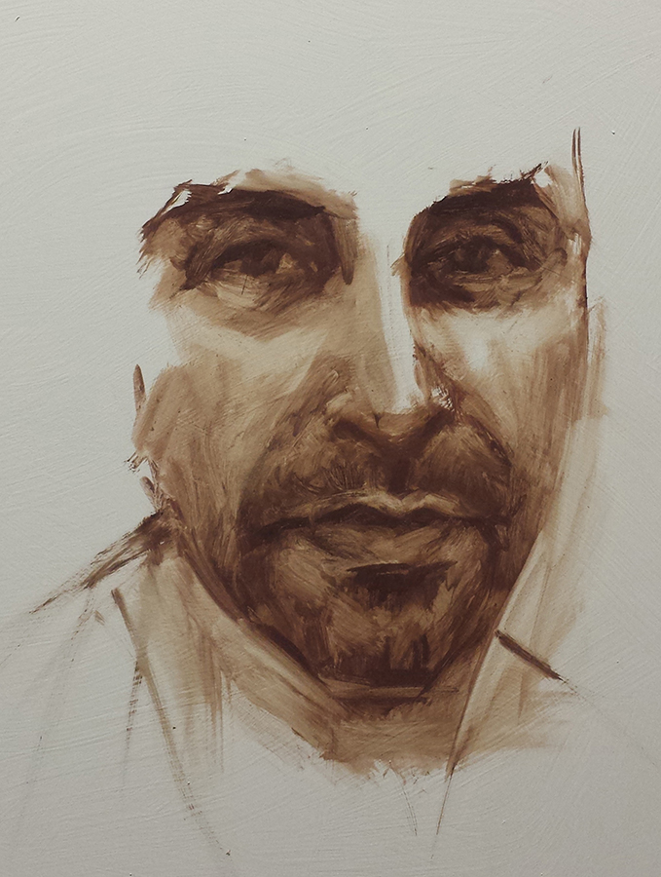 |  | John Scane  16 x 12 in.  oil on panel  $2,500.
BR. | 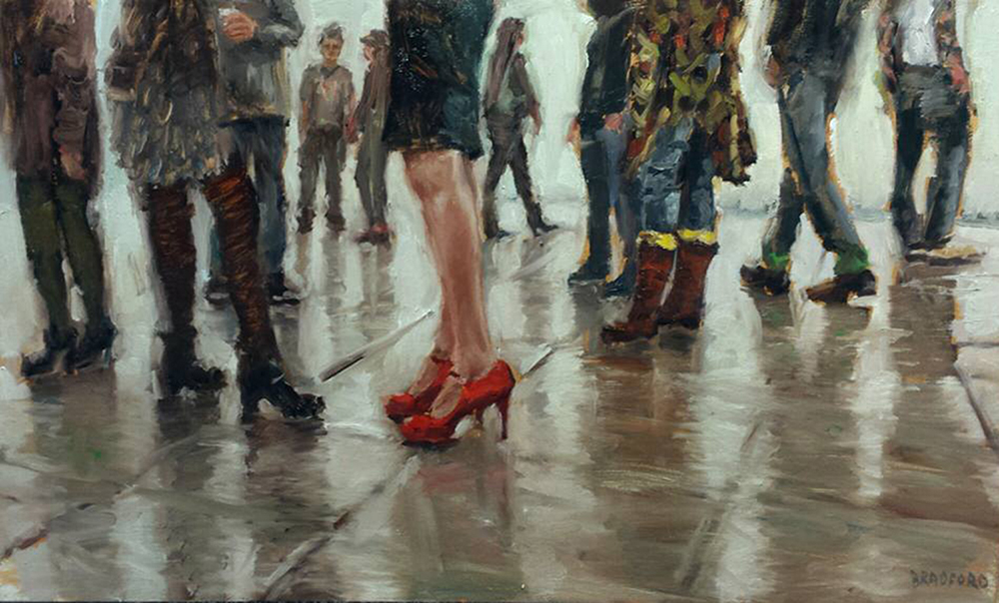 |  | Red Shoes  15 x 25 in.  oil on canvas  3,500.
BR.  BBR  BR. | 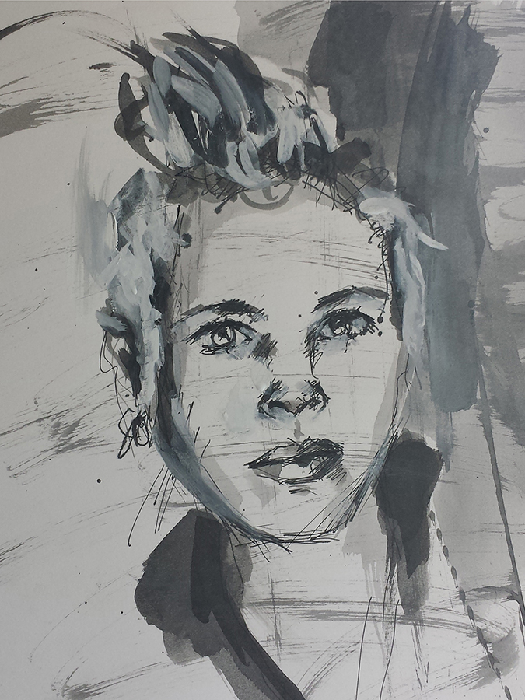 |  | Jennifer Celio  12 x 9 in.  india ink & gouache on watercolor paper  $1,400.
BR. | 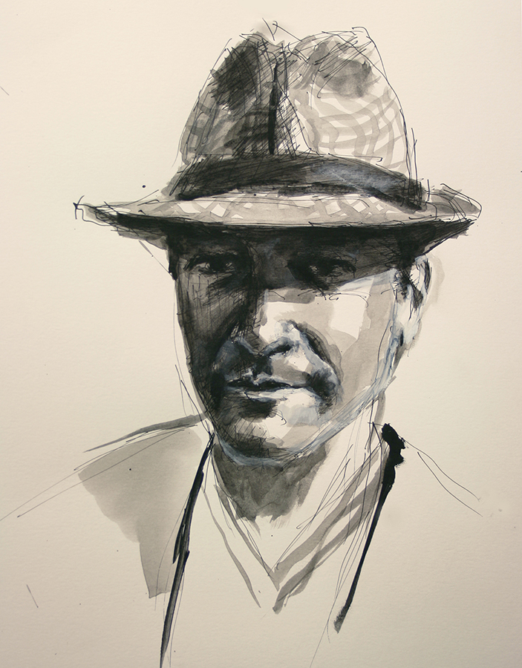 |  | Adam Stone  14 x 11 in.  india ink & gouache on watercolor paper  $1,500.
BR. | 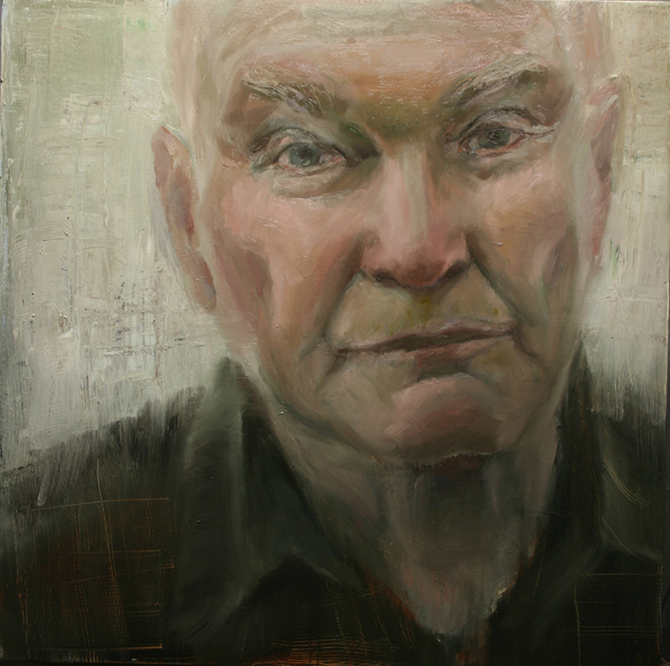 |  | Lou Swenson  36 x 36 in.  oil on canvas  $8,000.

