Ana Rodriguez – Abominable Gift Baskets
Nano Rubio – Fast & Hard
 |  | 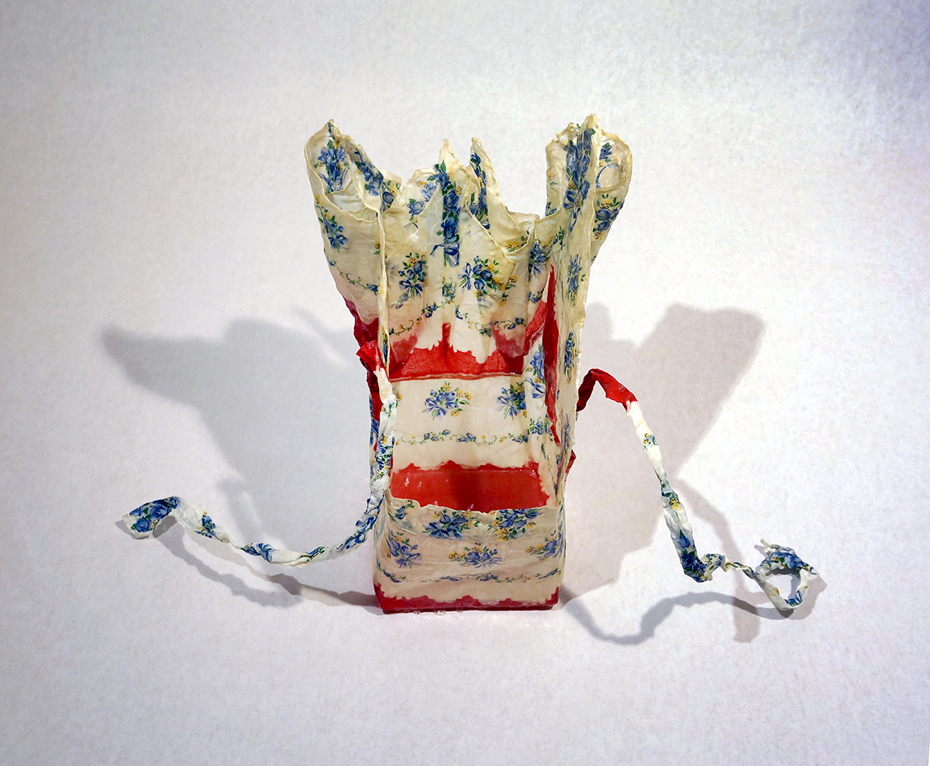 |  |  | Ching Ching Cheng  Apron series 31  Re-purposed apron, epoxy resin  15" x 15" x 4"  $800
 | 2. | 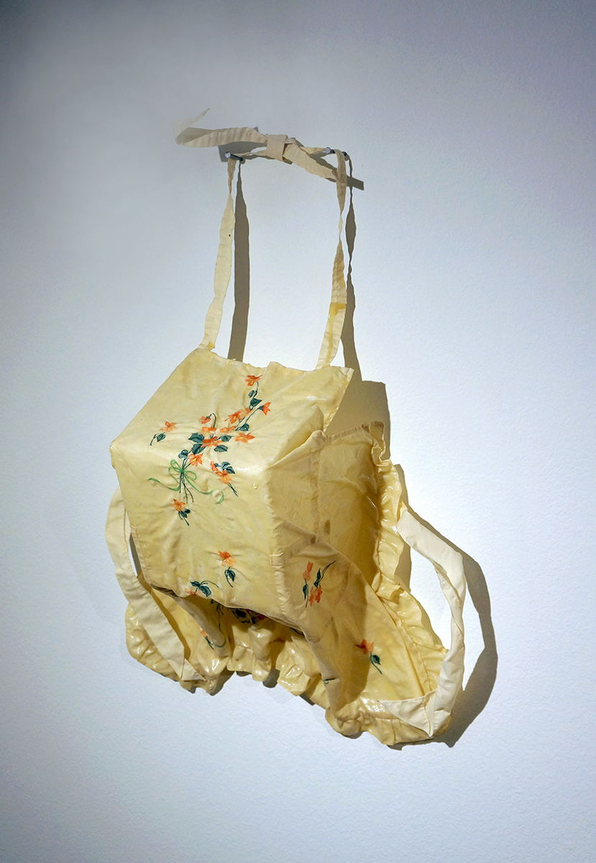 |  |  | Ching Ching Cheng  Apron series 32  Re-purposed apron, epoxy resin  24" x 20" x 8"  $900  .
 | 3. | 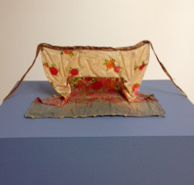 |  |  | . Ching Ching Cheng  Apron series 2  Re-purposed apron, epoxy resin, dye  8" x 15" x 9"  $800
 | 4. | 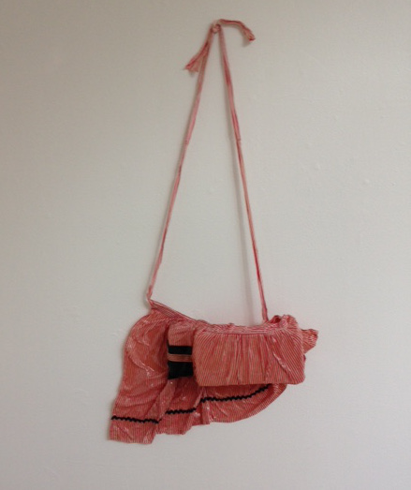 |  |  | Ching Ching Cheng  Apron series 4  Re-purposed apron, epoxy resin  10" x 20" x 20"  $850
 | 5. | 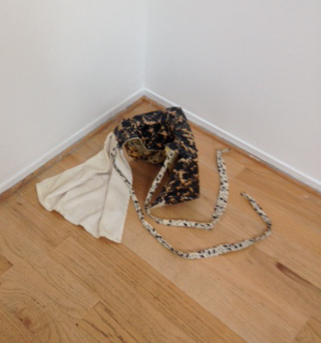 |  |  | Ching Ching Cheng  Apron series 12  Re-purposed apron, epoxy resin  5" x 18" x 13"  $800
 | 6. | 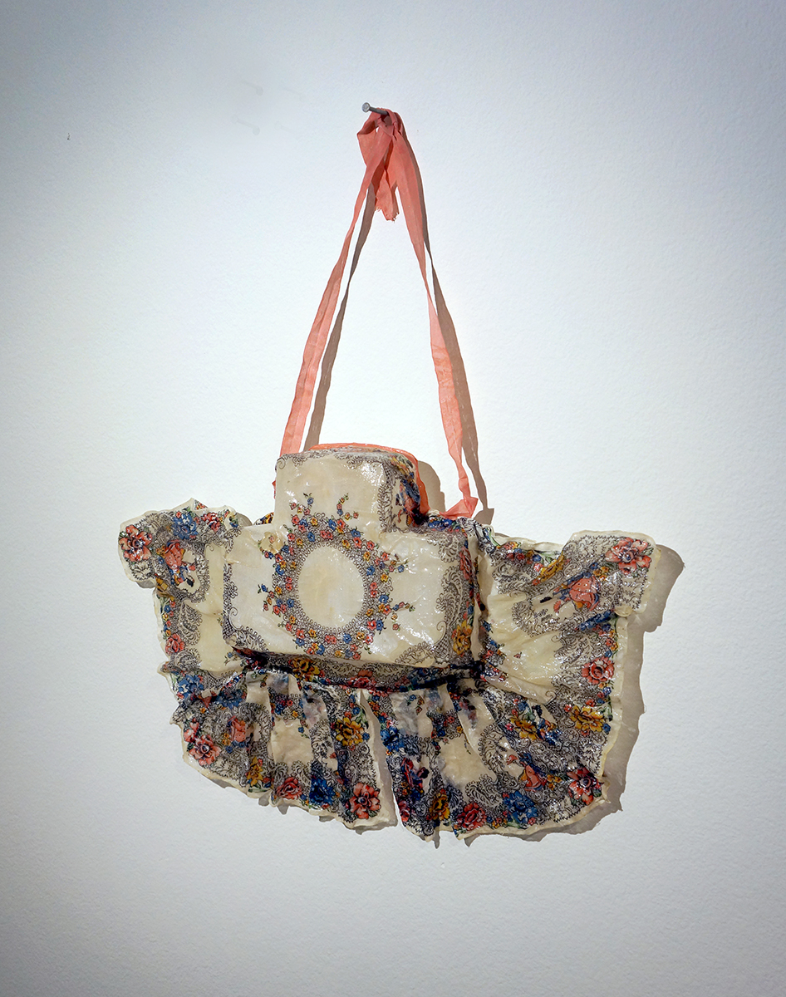 |  |  | Ching Ching Cheng  Apron series 34  Re-purposed apron, epoxy resin  20"x20"x4"  $800
7. |  | 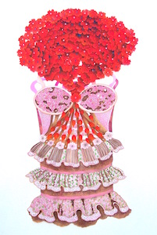 |  |  |  | Leigh Salgado  The “P” Word  Hand-cut paper with acrylic & eyelets  48 x 27 inches  $5,000  .
8. |  | 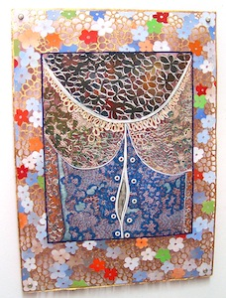 |  |  |  | Leigh Salgado  Look At Me  Hand-cut altered mono-type with acrylic & eyelets  18.5 x 13.5 inches  $1,800  .
9. |  | 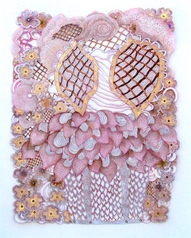 |  |  |  | Leigh Salgado  Busy Beaver  Hand-cut paper with acrylic & eyelets  29 x 22 inches  $2,400
10. |  | 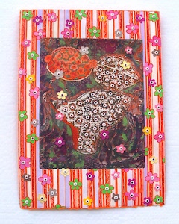 |  |  |  | Leigh Salgado  Vikki  Hand-cut altered mono-type with acrylic & eyelets  18 x 13 inches  $1,800
11. |  | 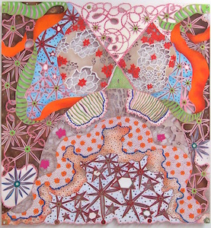 |  |  |  | Leigh Salgado  Dreaming of John  Hand-cut paper with acrylic & eyelets  31 x 29 inches  $4,000  .
12. |  | 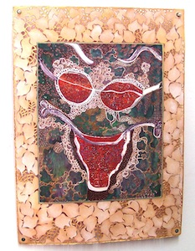 |  |  |  | Leigh Salgado  Look At Me, Look At Me  Hand-cut altered mono-type with acrylic & eyelets  18.5 x 13.5 inches  $1,800  .

13. | 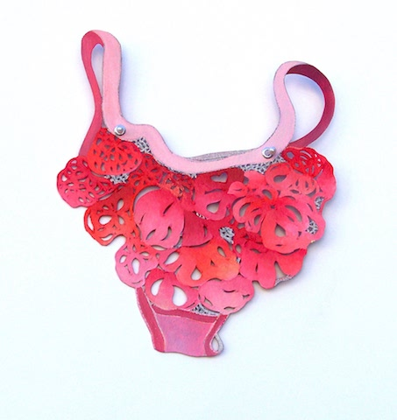 |  | Leigh Salgado  Bundle  Hand-cut paper with acrylic & eyelets  8.5 x 7.25 inches  $500
14. | 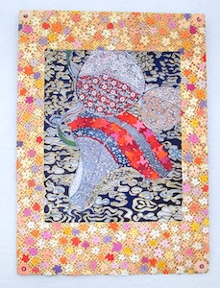 |  | Leigh Salgado  Victoria  Hand-cut altered mono-type with acrylic & eyelets  18 x 13 inches  $1,800
.  15. | 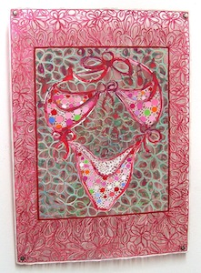 |  | Leigh Salgado  Look At Me, Look At Me, Look At Me, Look At Me  Hand-cut altered mono-type with acrylic & eyelets  18.5 x 13.5 inches  $1,800  .
16. | 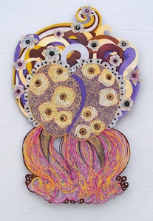 |  | Leigh Salgado  Queen B  Hand-cut paper with acrylic & eyelets  23 x 15 inches  $1,600
17. | 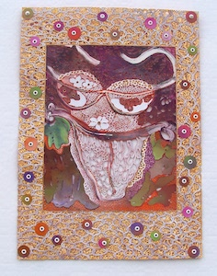 |  | Leigh Salgado  Tori  Hand-cut altered mono-type with acrylic & eyelets  18 x 13 inches  $1,800
18.. | 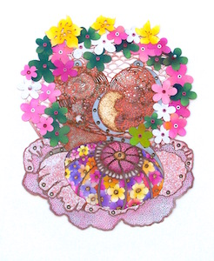 |  | Leigh Salgado  Love Child  Hand-cut paper with acrylic, burning & eyelets  18 x 15 inches  $1,600
19. | 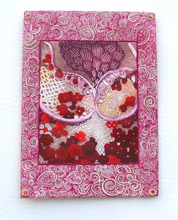 |  | Leigh Salgado  V Is For Victory  Hand-cut altered mono-type with acrylic & eyelets  18 x 13 inches  $1,800

20. | 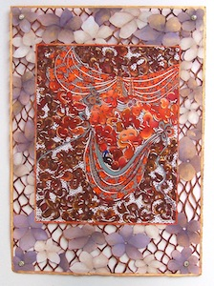 |  | Leigh Salgado  Look At Me, Look At Me, Look At Me  Hand-cut altered mono-type with acrylic & eyelets  18.5 x 13.5 inches  $1,800  .
21. | 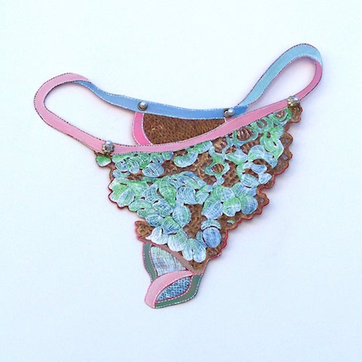 |  | Leigh Salgado  Wad  Hand-cut paper with acrylic & eyelets  8.75 x 9 inches  $500
22.  BBR  BR. | 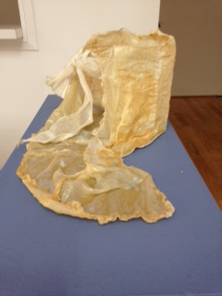 |  | Ching Ching Cheng  Apron series 1  Re-purposed apron, epoxy resin  8" x 16" x 12"  $800
23. | 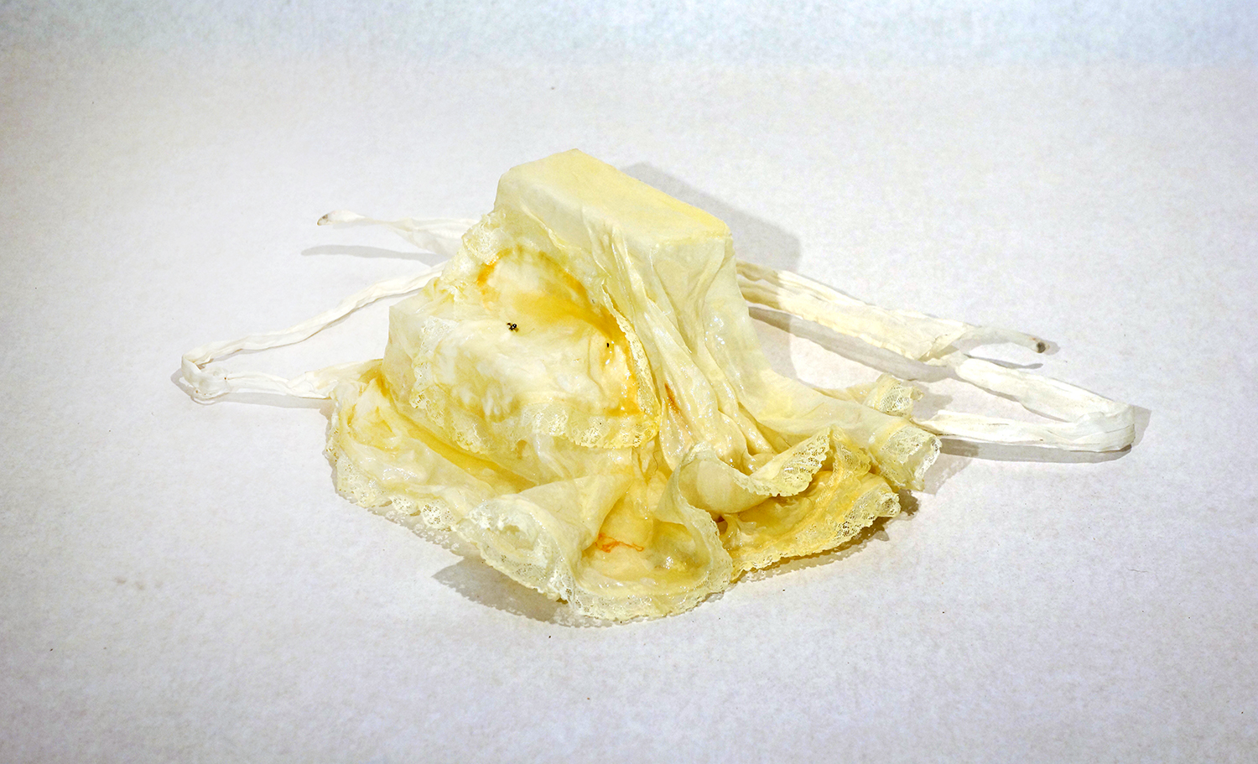 |  | Ching Ching Cheng  Apron series 28  Re-purposed apron, epoxy resin  10" x 15" x 12"  $800
24. | 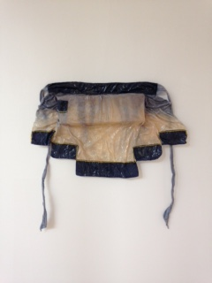 |  | Ching Ching Cheng  Apron series 10  Re-purposed apron, epoxy resin, dye  13" x 22" x 3"  $800
BR. | 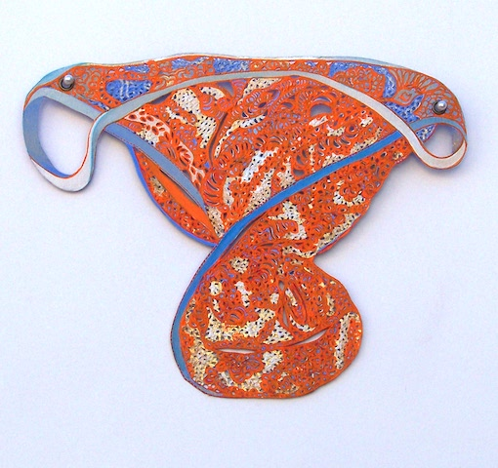 |  | Leigh Salgado  Twist  Hand-cut paper with acrylic, burning & eyelets  9.25 x 7.25 inches  $500
BR. | 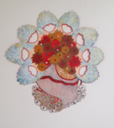 |  | Leigh Salgado  The Real Thing (for Phyllis)  Acrylic & eyelets on hand-cut paper  19.5 x 19 inches  $1,500
BR. | 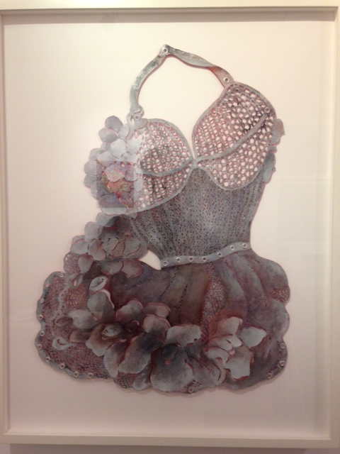 |  | Leigh Salgado  Birdcage  Acrylic on hand-cut paper  26 x 21 inches  $2,000

