 |  |  | 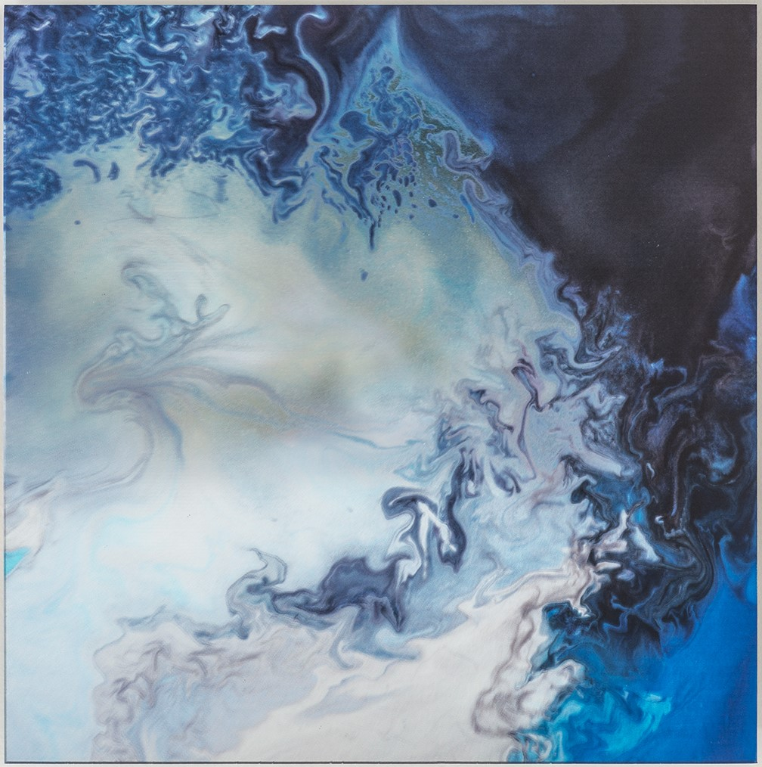 |  |  | GDB Deep Water II, 2014  mixed media on acrylic with color shifting powders  16” x 16”  $2400  .
 | 2. |  | 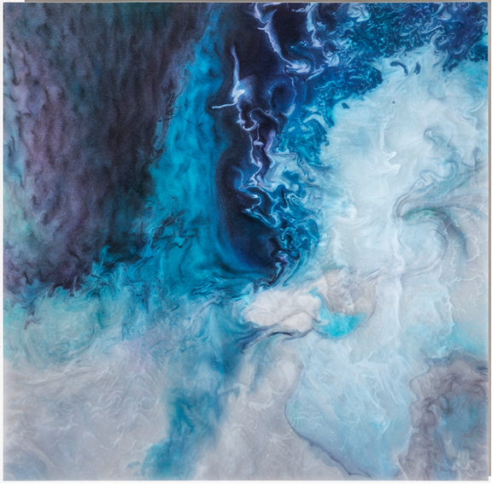 |  |  | GDB Deep Water I, 2014  mixed media on acrylic with color shifting powders  16” x 16”  $2400  .
 | 3. |  | 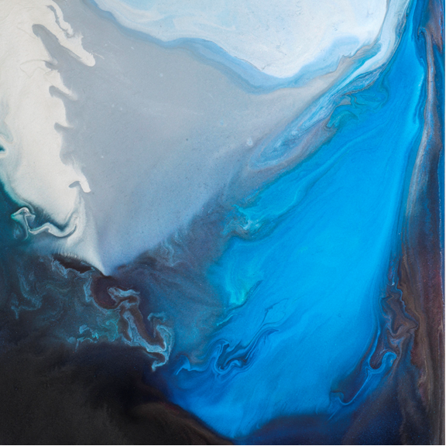 |  |  | .  GDB Deep Water III, 2014  mixed media on acrylic with color shifting powders  16” x 16”  $2400
 | 4. |  | 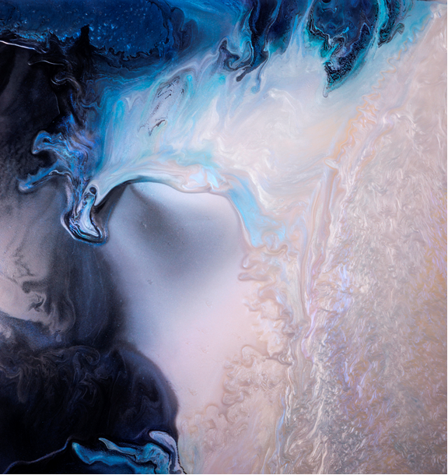 |  |  | . GDB Deep Water IV, 2014  mixed media on acrylic with color shifting powders  16” x 16”  $2400
 | 5. |  | 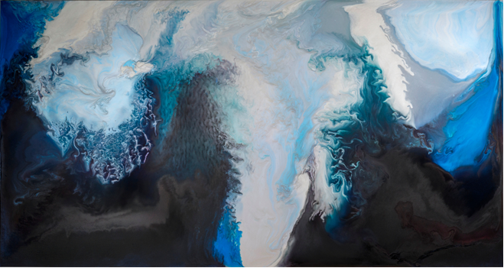 |  |  | Galactic Dust Bunnies, 2015  acrylic on panel with color shifting powders  48” x 90”  $20,000
 | 6. |  | 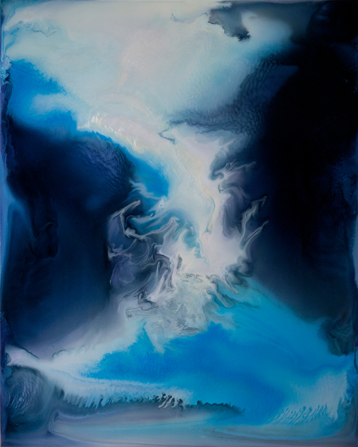 |  |  | Light Visitation, 2015  30 x40"  Mixed media light box  Edition of 5  $7,000
7. |  |  |  |  |  |  | Cole James  Blue Felon, 2015  Acrylic on Satin.  60”x 50” varied  $800.
8. |  |  |  |  |  |  | Cole James  Lung Fruit, 2012  Tar, Rubber, Satin ,Pearl  Appliques, Acrylic & Glitter Foam  Stretched Satin.  24x18 inches  $500.
9. |  |  |  |  |  |  | Ana Rodriguez  Untitled, 2015  Acrylic, oil on canvas  17.5" x 13.5 " framed  $600.
10. |  |  |  |  |  |  | Ana Rodriguez  Untitled, 2015  Acrylic, oil on canvas  21.5" x 17.5 " framed  $600.
11. |  |  |  |  |  |  | Ana Rodriguez  Untitled, 2015  Acrylic, oil on canva  17.5" x 13.5 " framed  $600.
12. |  |  |  |  |  |  | . Ana Rodriguez  Untitled, 2015  Acrylic, oil on canvas  21.5" x 17.5 " framed  $600.

13. |  |  | Ana Rodriguez  Untitled, 2015  Acrylic, oil on canvas  17.5" x 13.5 "  $600.
14. |  |  | Cole James  Spotted Purple Fruit, 2012  Tar, Rubber, Satin, Pearl Appliques, Acrylic & Glitter  Foam on Stretched Satin.  24” x 18”  $500.  $500
.  15. |  |  | Cole James  ex-exal.ta.taion,2014  Ink on vellum, framed  11" x 8 "  $250.
16. |  |  | Cole James  No Cover Speak Easy, 2014  Ink on vellum, framed  11" x 8 "  $250.
17. |  |  | Cole James  Racion ,2014  Ink on vellum, framed  16" x 13 "  $350.
18. |  |  | Cole James  Bring In The Pawn, 2012  Tar, Rubber, Satin, Pearl Appliques, Acrylic & Glitter  Foam on Stretched Satin.  24” x 18”  $500.
BR. |  |  | Cole James  The Weight of My Fist, 2015  Satin, Acrylic, Paper, Lace on Quilted Satin,  Canvas  48” x 36”  $1300.

BR. |  |  | Ana Rodriguez  Untitled, 2015  Paper collage  21.5" x 17.5 " framed  $750.
BR. |  |  | Ana Rodriguez  Untitled, 2015  Paper collage  15.5" x 12.5 " framed  $750.
BR.  BBR  BR. |  |  | Ana Rodriguez  Untitled, 2014  Acrylic, oil on panel  24” x 18”  $950.
BR. |  |  | Ana Rodriguez  Untitled, 2012  Acrylic, oil on panel  24” x 18”  $650.
BR. |  |  | Cole James  Fly By Eves, 2014  Ink on vellum, framed  16" x 13"  $350.

