1. | 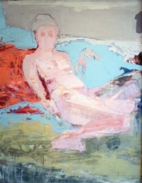 |  | Andrea Patrie  Homage Ingres  oil on canvas  56 x 48” | $3,500
2. | 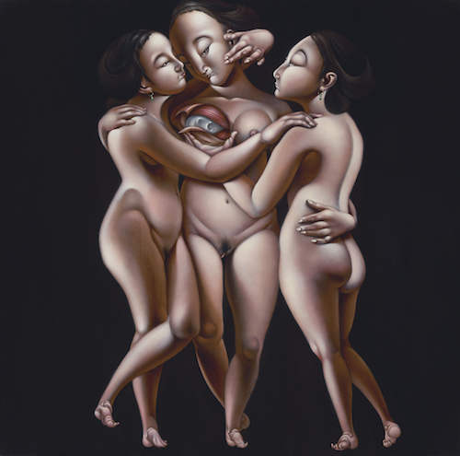 |  | Phung Huynh  The Three Graces  oil on canvas  36 x 36”  2017 | $7,500
3. | 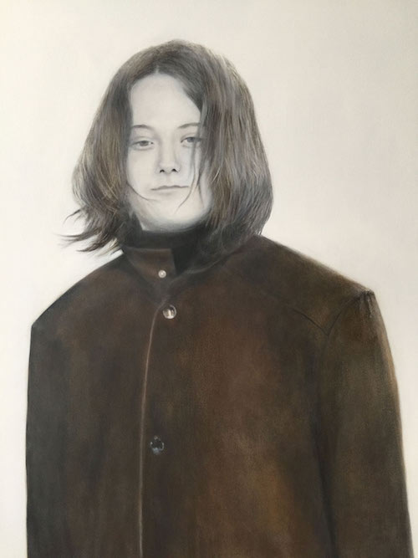 |  | Deborah Martin  Elizabeth at Fourteen ( part of the the Portraits of Autism series )  oil on canvas  36 x 48 | NFS
4. |  |  | J Michael Walker  Zelda  photo 30" high x 22" wide,  printed on Arches 300lb. Mouldmade watercolor paper 2010 | $1,600
5. |  |  | J Michael Walker  Isa  photo 30" high x 22" wide,  printed on Arches 300lb. Mouldmade watercolor paper 2016 | $1,600
6. |  |  | J Michael Walker  Esi  photo 30" high x 22" wide,  printed on Arches 300lb. Mouldmade watercolor paper 2013 | $1,600
7. |  |  | J Michael Walker  Patricia  photo 30" high x 22" wide,  printed on Arches 300lb. Mouldmade watercolor paper 2010 | $1600
8. |  |  | J Michael Walker  Aliza  photo 30" high x 22" wide,  printed on Arches 300lb. Mouldmade watercolor paper 2018 | $1600
9. | 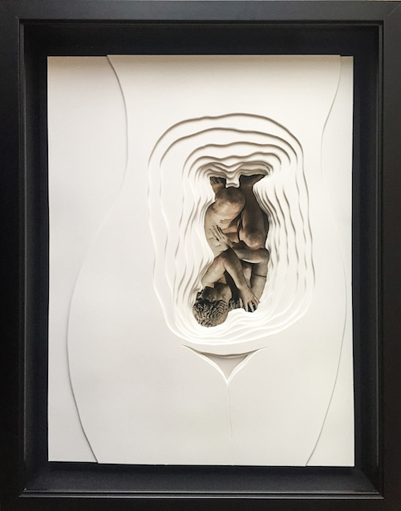 |  | Sara Alavikia  Cesarean of the Goddess,  Mixed media, 2017  16 x 12” | $6,600
10. | 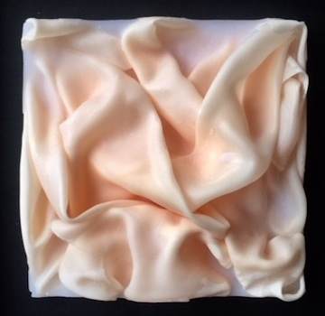 |  | Sara Alavikia  Enclosed Beauty  Fabric and wax 2018  6 x 6 x 3” | $4000
11. | 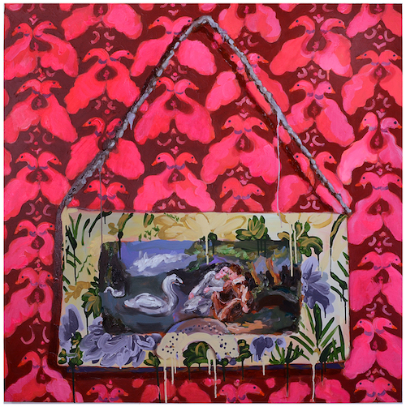 |  | Annelie McKenzie  Swan Problems, 2018  oil and acrylic on canvas  48 x 48” | $4000
12. | 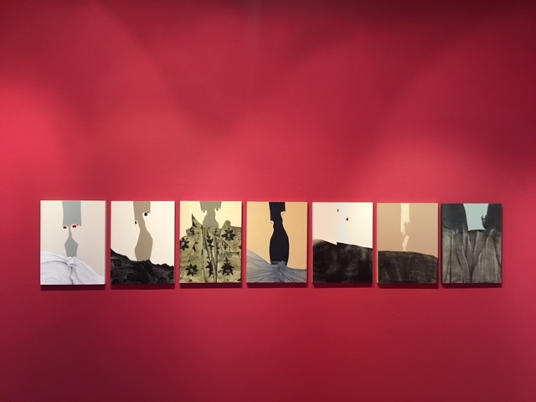 |  | Cima Rahmankhah  Ex Nihilo Series Day and Night, #1, 2, 3, 4, 5, 6, 7  enamel and oil paint on board 2017  16 x 20” | $1,200/each
13. | 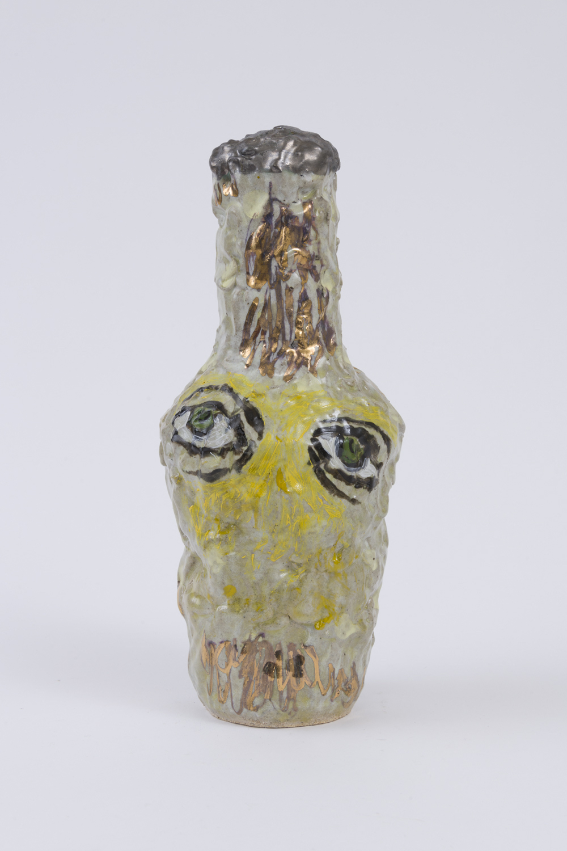 |  | Kim Tucker  Vessel of Yellow, 2018  ceramic  14 x 6 x 6” | $700
14. | 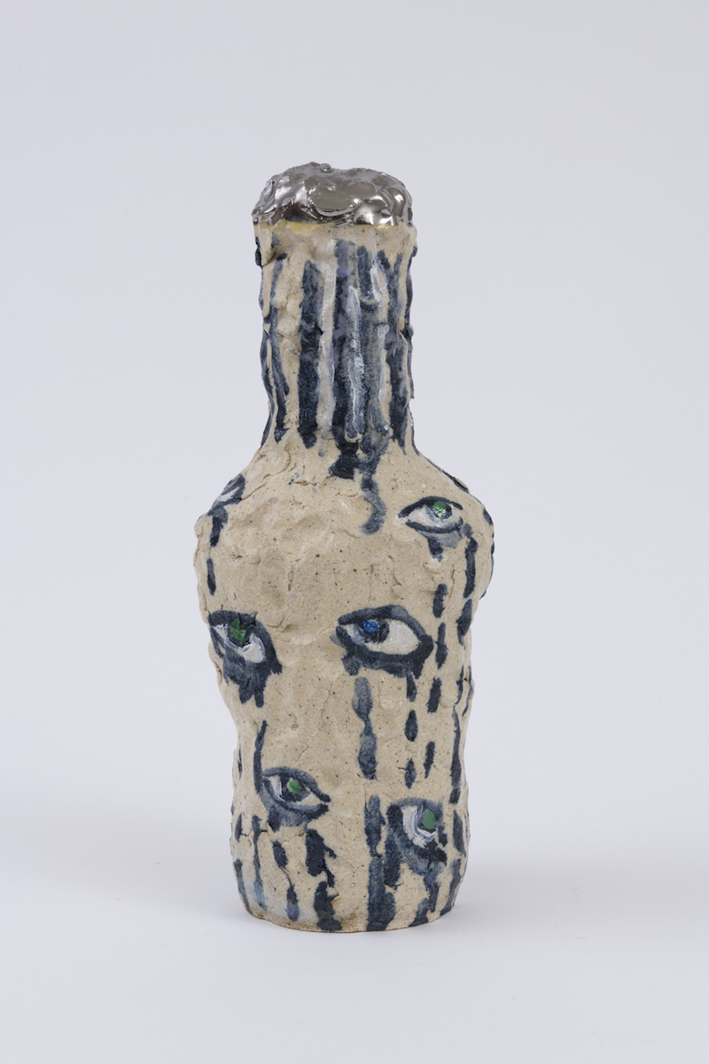 |  | Kim Tucker  Vessel of Gold Dust, 2018  ceramic  14 x 6 x 5” | $700
15. | 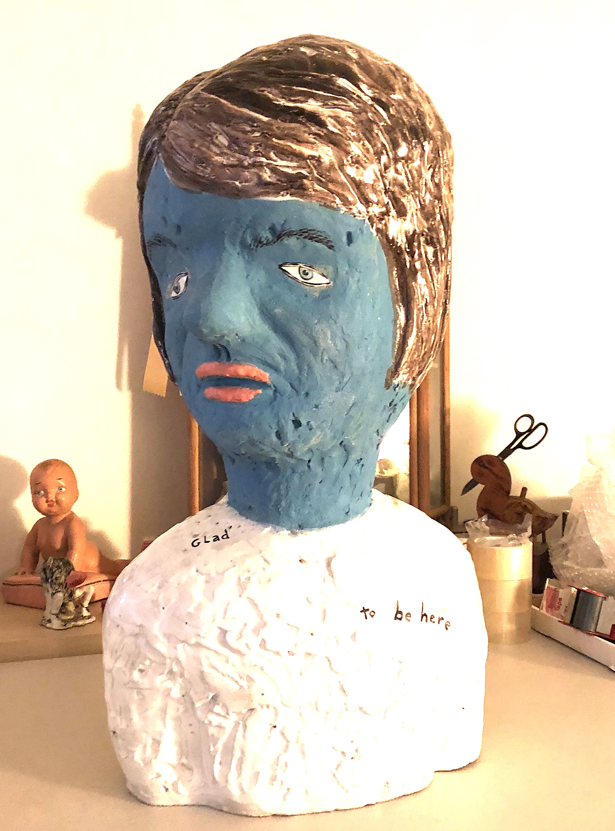 |  | Kim Tucker  Glad to be Here, 2012  ceramic  29 x 17 x 10” | $3,500
16. | 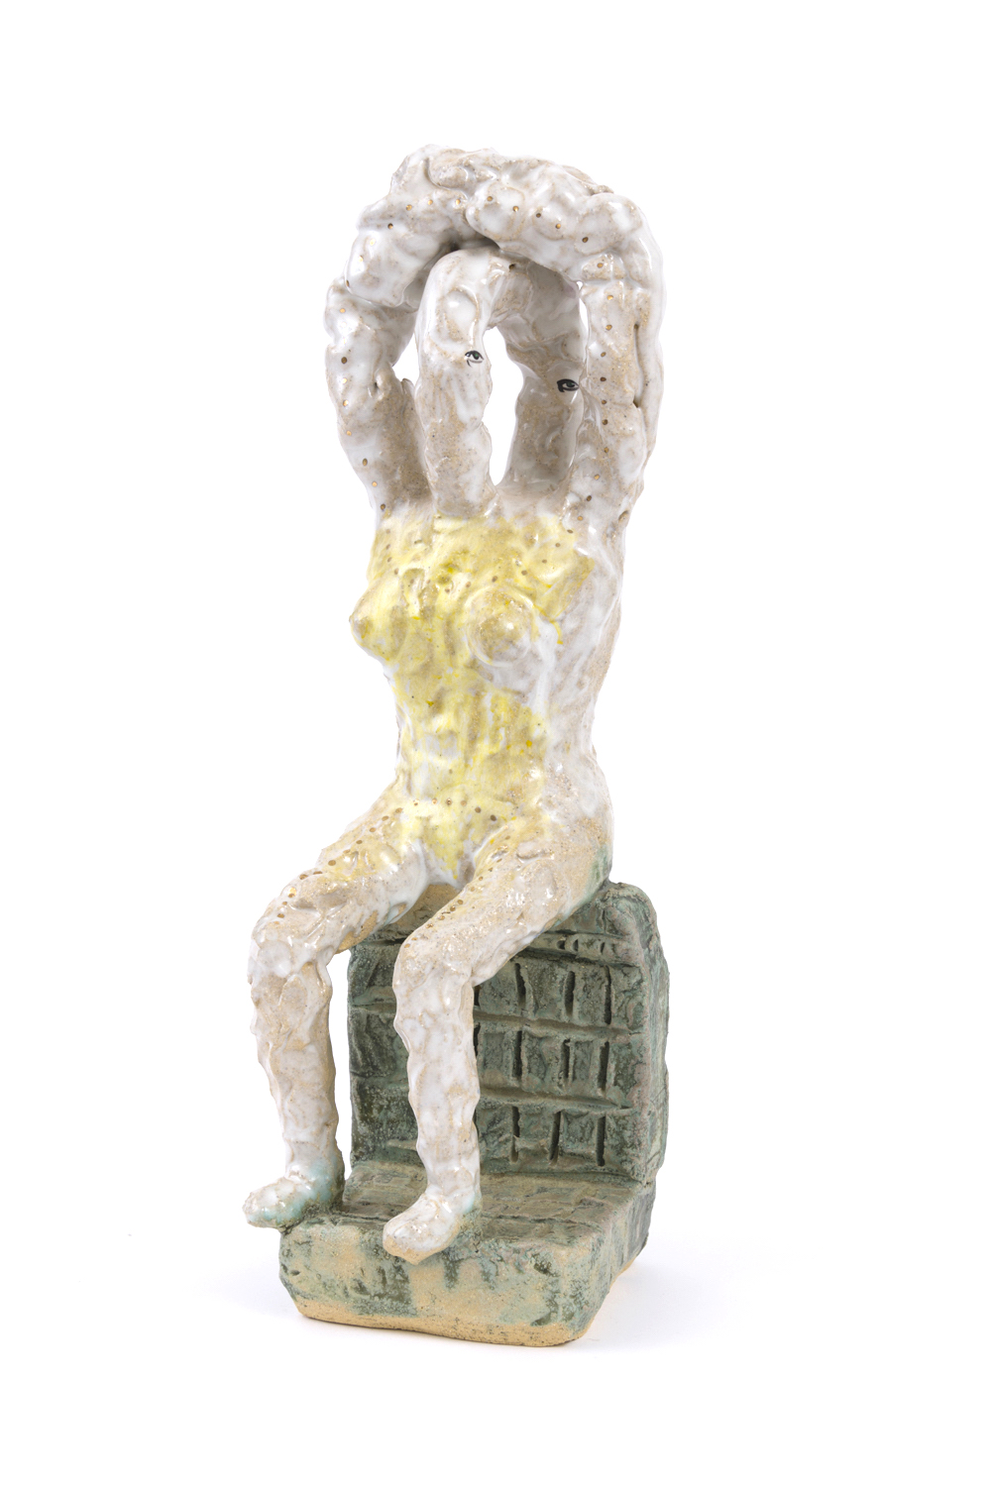 |  | Kim Tucker  From everything and now, 2018  ceramic  20 x 7 x 7” | $1,200
17. | 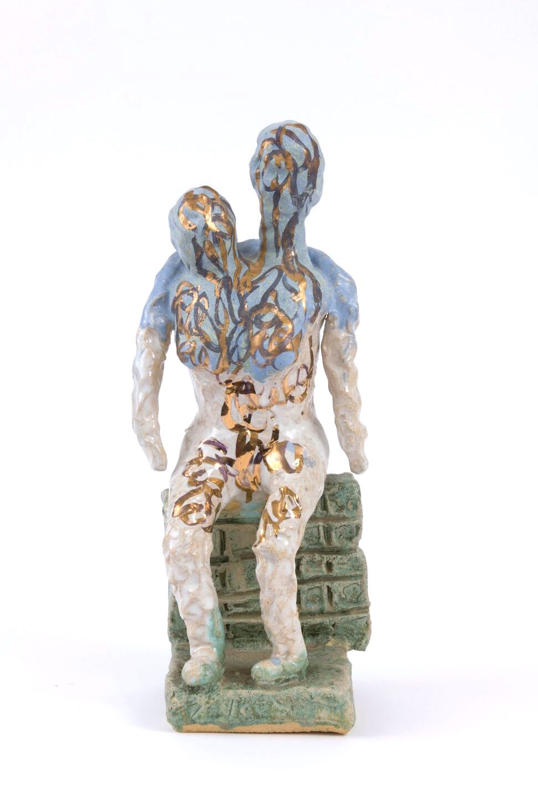 |  | Kim Tucker  From past loves and hate, 2018  ceramic  17 x 7 x 6” | $1200
18. | 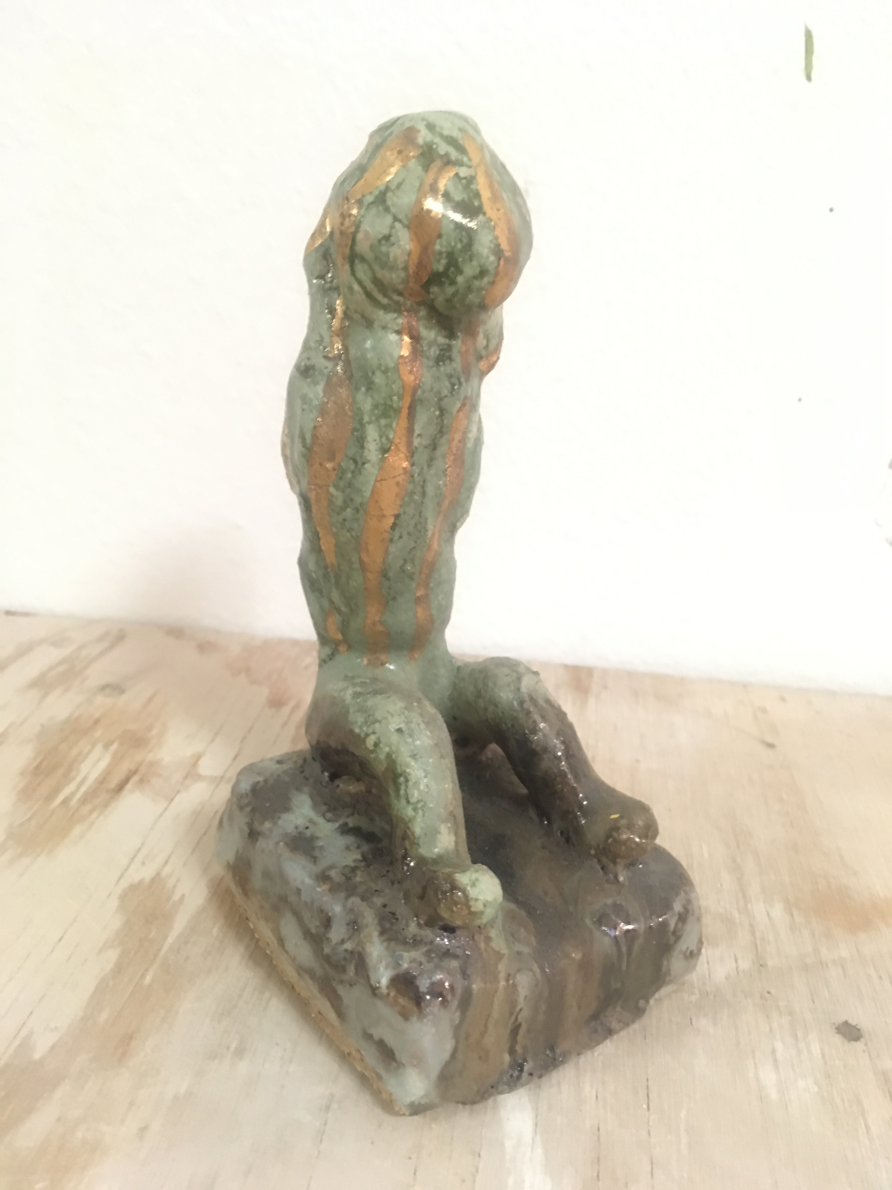 |  | Kim Tucker  Primordial body VII, 2018  ceramic  6.5 x 3 x 3” | $425
19. | 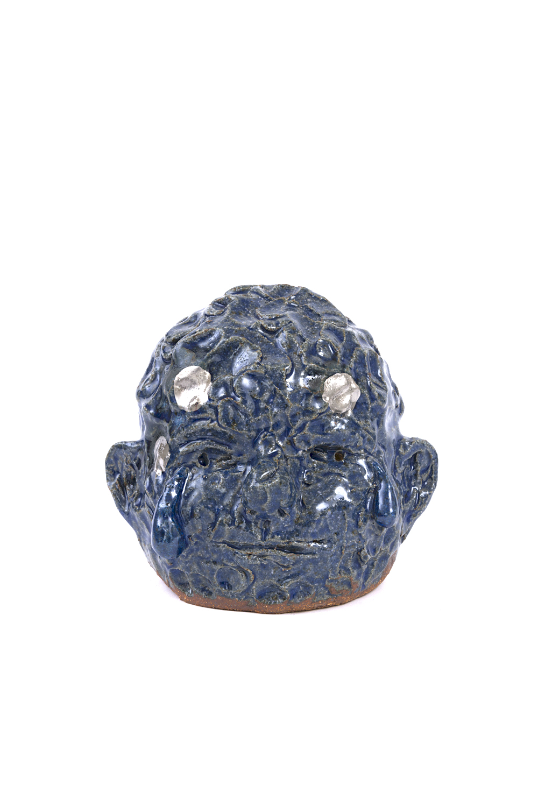 |  | Kim Tucker  Babyface, 2018  ceramic  6 x 6 x 6” | $425
20. | 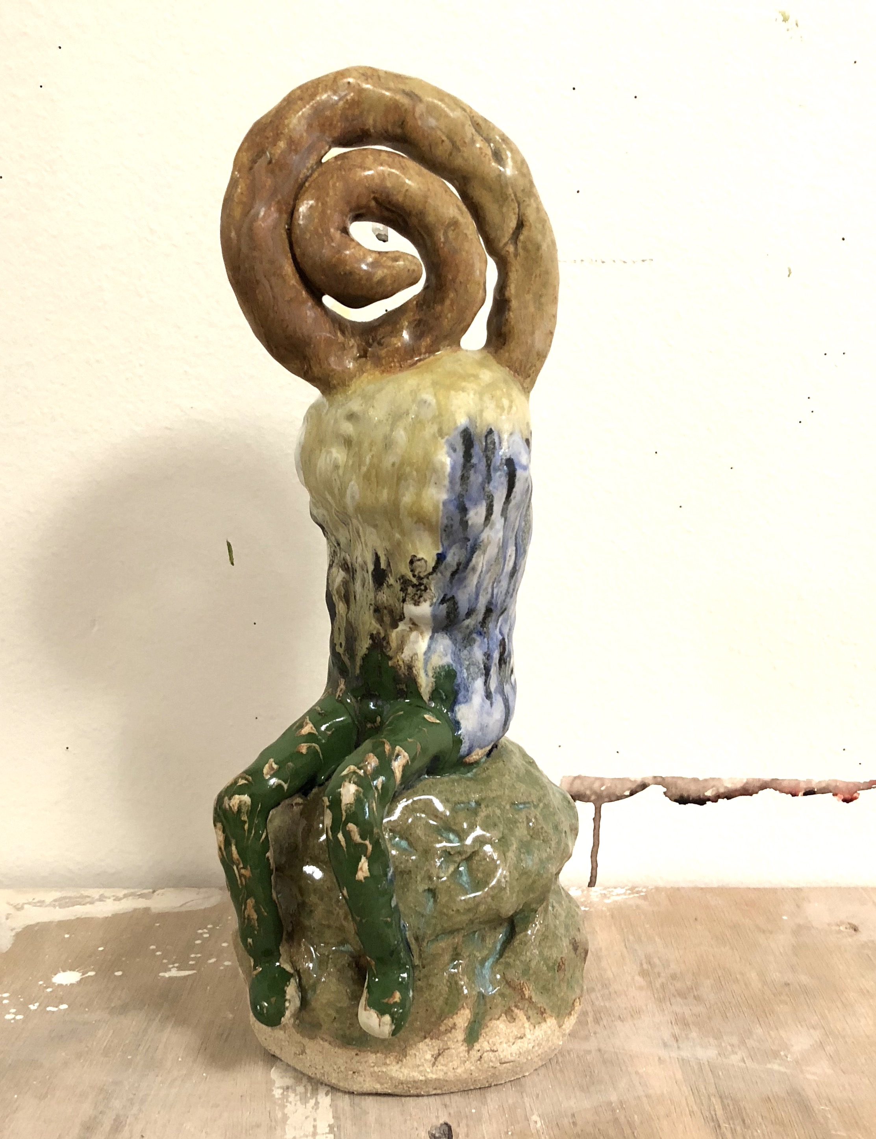 |  | Kim Tucker  Beginingendbody, 2018  ceramic  15 x 6x 6” | $750
21. | 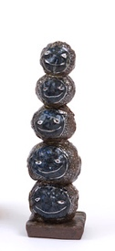 |  | Kim Tucker  Moon Stack, 2018  ceramic  10 x 3 x 3” | $425
22. | 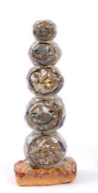 |  | Kim Tucker  Sun Stack, 2018  ceramic  10 x 3 x 3” | $425
23. | 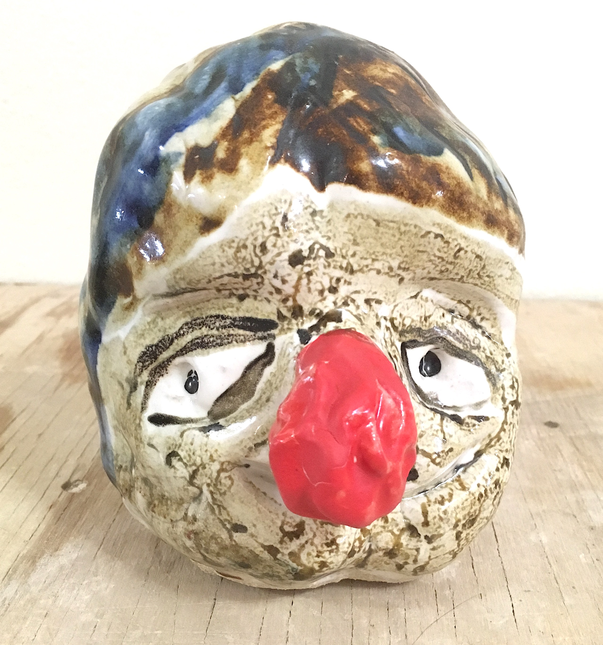 |  | Kim Tucker  Portrait Head, 2018  ceramic  6 x 5x 5” | $425 | Back  Room
24. | 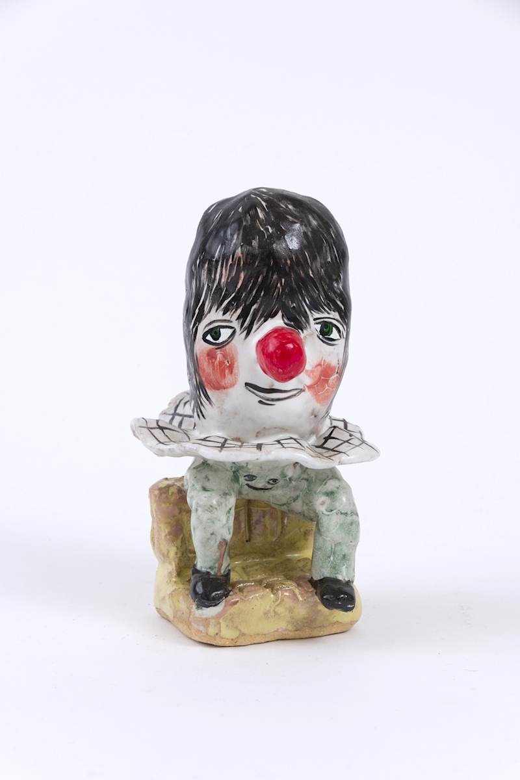 |  | Kim Tucker  Smileypants, 2018  ceramic  6.5 x 2.34 x 2.5” | $450 | Back Room
25. | 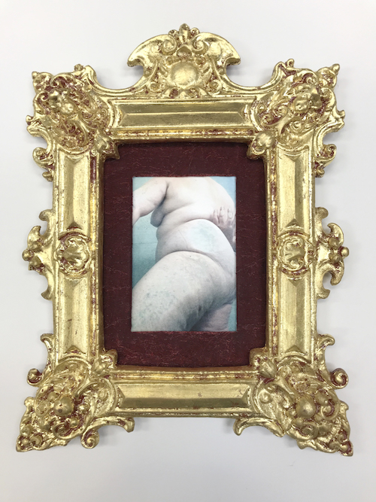 |  | Kristine Schomaker  Plus, Private Residence November 1, 2017  Photo with gold leafed frame  5 x 7” | $600
26. | 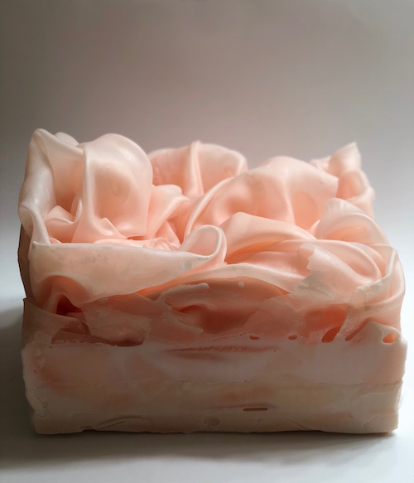 |  | Sara Alavikia  Beautiful Burden  Fabric and wax 2018  12 x 9 x 4” | $8,000
27. | 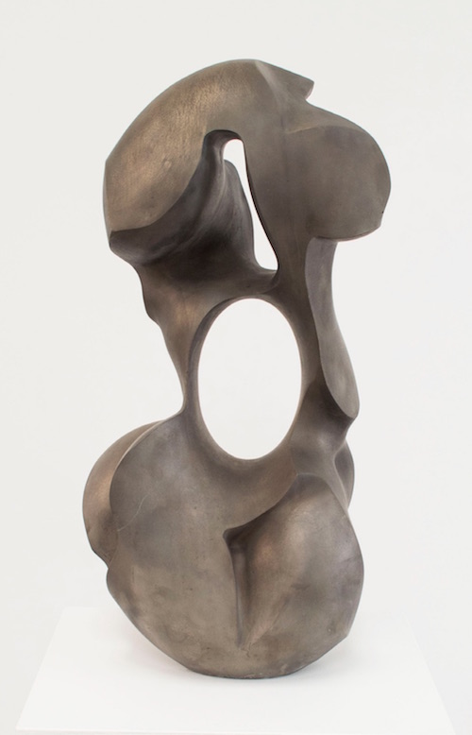 |  | Douglas Tausik Ryder  Myth of Beauty 2016  Bronze  27.5”h x 13”w x 8.5”d | $18,000  edition of 6
28. | 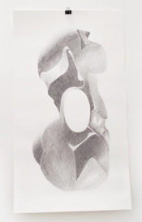 |  | Douglas Tausik Ryder  Myth of Beauty 2016  Giclée print on Rag Paper  40“h x 23“w  Edition of 12 | $300

