Short Days Dark Nights ~ Kim Kimbro, Michael Rosenfeld, Theodore Svenningsen, William Wray
 |  |  | 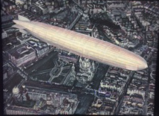 |  |  | Michael Rosenfeld  Europa II  oil on canvas  9” x 12”  $425.  .
 | 2. |  | 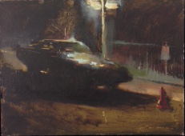 |  |  | William Wray  Stygian  Oil on panel  11” x 14”  $1600  .
 | 3. |  | 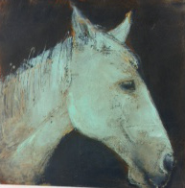 |  |  | Kim Kimbro  Green Horse Study  Oil on canvas,  10” x 10”  $500.
 | 4. |  | 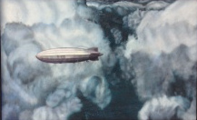 |  |  | Michael Rosenfeld  Redemption  oil on canvas,  26” x 32”  $2400.
 | 5. |  | 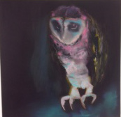 |  |  | Kim Kimbro  though she cried her last tears, there were more the next morning  oil on canvas,  18” x 18”  $1100.
 | 6. |  | 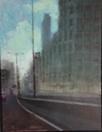 |  |  | William Wray  Guardrail  Oil on panel  36 x 24  $3800.
7. |  | 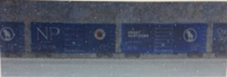 |  |  |  |  | Theodore Svenningsen  Great Northern and Northern Pacific  acrylic on canvas  20” x 60″  $4500
8. |  | 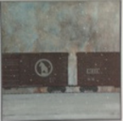 |  |  |  |  | Theodore Svenningsen  Great Northern  acrylic on canvas  30” x 30″  $3000.
9. |  | 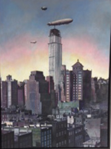 |  |  |  |  | Michael Rosenfeld  Troika  oil on canvas  48” x 36″  $5100.
10. |  | 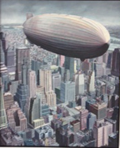 |  |  |  |  | Michael Rosenfeld  Atlantic II  oil on canvas  42" x 34 " framed  $4200.
11. |  | 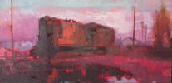 |  |  |  |  | William Wray  Red Train  oil on panel  24" x 48 "  $4800.
12. |  | 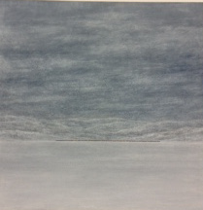 |  |  |  |  | . Theodore Svenningsen  Montana Morning  acrylic on canvas  30 x 30 in.  $3000.

13. | 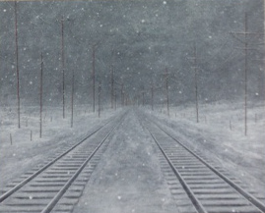 |  | Theodore Svenningsen  Track on a Winter Day  Acrylic on canvas  24" x 30 "  $3000.
14. | 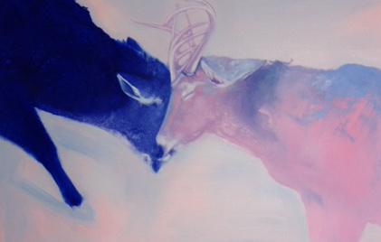 |  | Kim Kimbro  The Secret Knot  oil on canvas,  40” x 60″  $4200.
.  15. | 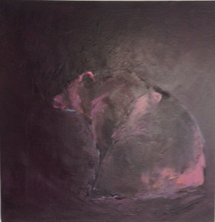 |  | Kim Kimbro  The Longing  oil on canvas  24” x 24”  $1800.
16. | 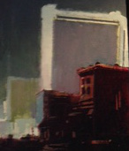 |  | William Wray  Hilton  oil on panel  18 in. x 14 in.  $2200.
17. | 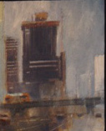 |  | William Wray  LA Rain  oil on panel  15 in. x 12 in.  $1800.
18. | 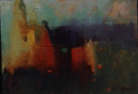 |  | William Wray  Tabernacle  oil on panel  20 in. x 16 in.  $1800.  .  $1200. each
19. | 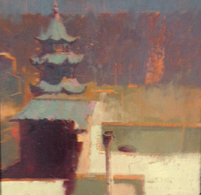 |  | William Wray  Hop  oil on panel  16” x 16”  $2200.

20. | 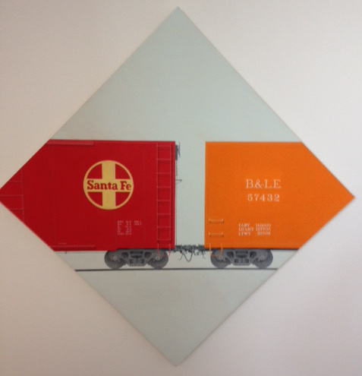 |  | Theodore Svenningsen  Sante Fe  acrylic on canvas  34" x 34 "  $2500.
21. | 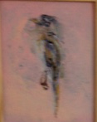 |  | Kim Kimbro  Bird Study on Pink  8" x 10 "  $500.
22.  BBR  BR. | 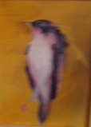 |  | Kim Kimbro  Purple Bird Study on Yellow  oil on panel  8” x 10”  $500.
23. | 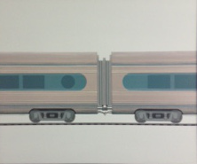 |  | Theodore Svenningsen  Silver Train  Acrylic, oil on panel  24” x 28”  $2500.
24. | 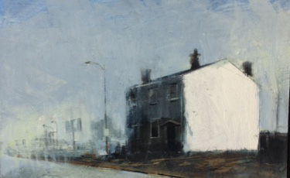 |  | William Wray  Cleveland  oil on panel  16" x 24"  $3000.
25. | 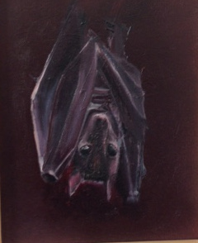 |  | Kim Kimbro  Bat Study  oil on panel  8” x 10”  $500.
26. | 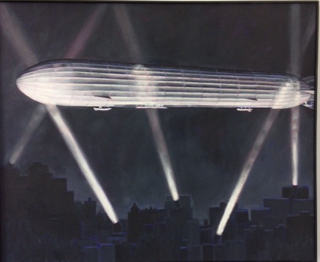 |  | Michael Rosenfeld  Nightwatch II  oil on canvas  36" x 44 "  $4600.
27. | 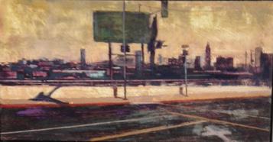 |  | William Wray  Eastward View  Acrylic, oil on canvas  16" x 32 "  $3200.
28. | 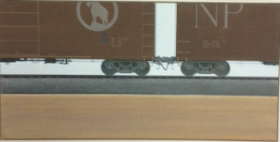 |  | Theodore Svenningsen  Great Northern and Northern Pacific 2  acrylic on canvas  15” x 30”  $1600.
29. | 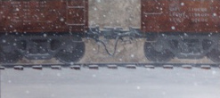 |  | Theodore Svenningsen  Coupling (two cars)  acrylic on panel  11” x 24”  $2000.
30. | 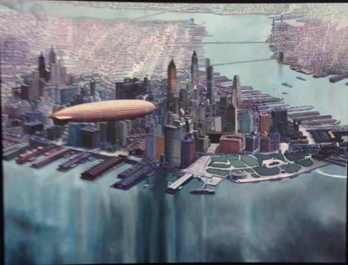 |  | Michael Rosenfeld  Blue City II  oil on canvas  35" x 46 "  $4800.
31. | 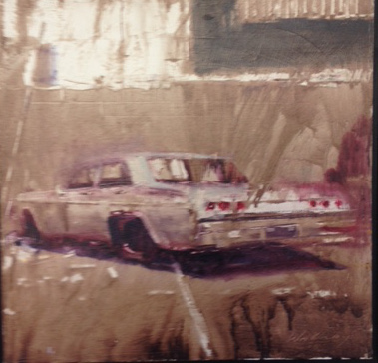 |  | William Wray  Appropriated Image  oil on panel  24" x 24 "  $3200.
32. | 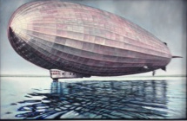 |  | Michael Rosenfeld  Floater III  oil, acrylic on canvas  22" x 34 "  $2200.
33. | 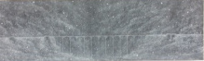 |  | Theodore Svenningsen  Long Trestle  acrylic on panel  11” x 36”  $2000.
34. | 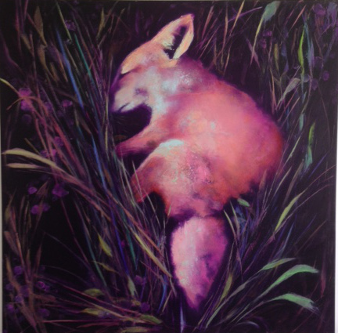 |  | Kim Kimbro  Grief and ruins and you were the miracle  oil on panel  36” x 36”  $3200.
35. | 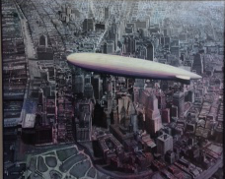 |  | Michael Rosenfeld  Eye in the Sky II  Acrylic, oil on panel  72” x 60”  $12,500.

