 | 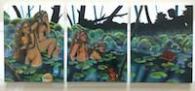 | Loren Holland  The Bathers  Oil on Canvas, Triptych  12” x 30”, 2016 | ON HOLD
2. | 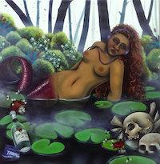 | Loren Holland  Naiad  Oil on Canvas  16” x 16”, 2016 | ON HOLD
3. | 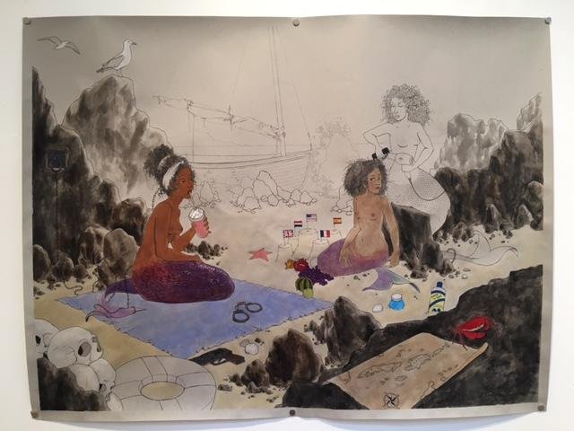 | Loren Holland  The Sirens  Ink and Watercolor on Paper  32” x 42”, 2017 | $1,500
4. | 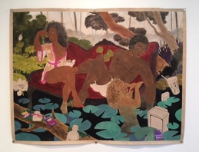 | Loren Holland  The Lotus-Eaters  Ink and Watercolor on Paper  32” x 42”, 2017 | $1,500
5. | 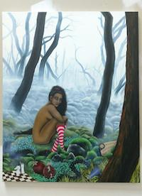 | Loren Holland  The Shadow Queen  Oil on Canvas  30” x 24”, 2016 | ON HOLD
6. | 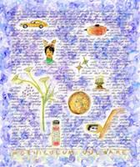 | Zeal Harris  Color of Jacarandas in South South LA  Dye Sublimation on Fabric  2/5 exclusive limited edition  20” x 17”, 2017 | $550
7. | 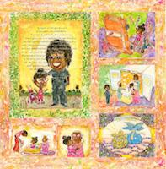 | Zeal Harris  Parable of Black Governance  Dye Sublimation on Fabric  1/5 exclusive limited edition  28” x 29”, 2017 | $900
8. | 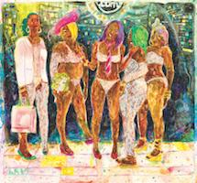 | Zeal Harris  Sweet Sticky Things  Dye Sublimation on Fabric  1/5 exclusive limited edition  44” x 41”, 2017 | $2,400
9. | 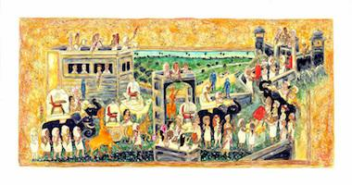 | Zeal Harris  Women in White Meet at the Wall  Dye Sublimation on Fabric  2/5 exclusive limited edition  24” x 46”, 2017 | $1,200
10. | 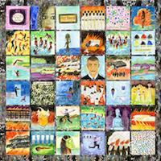 | Zeal Harris  Liturgical Language of a Free Traveler  Dye Sublimation on Fabric with  Sequins, Glue, Ribbon Trim  1/5 exclusive limited edition  55” x 55”, 2017 | $2,200
11. | 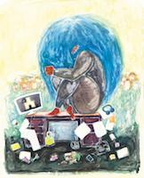 | Zeal Harris  Username  Dye Sublimation on Fabric  1/5 exclusive limited edition  25” x 20”, 2017 | $800
12 | 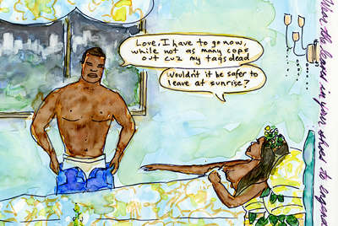 | Zeal Harris  Knight Stealth  Dye Sublimation on Fabric  2/5 exclusive limited edition  15” x 10”, 2017 | $400
13. |  | Zeal Harris  Black Girl Magic Wand: Ezrulie  Dye Sublimation on Fabric with  Glue and Beads  1/5 exclusive limited edition  50.5” x 7.5”, 2017 | $650
14. | 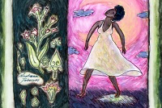 | Zeal Harris  Advice From Judea Falaise  Dye Sublimation on Fabric  2/5 exclusive limited edition  15” x 10”, 2017 | $400
15. | 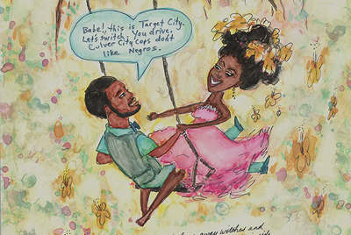 | Zeal Harris  Target City  Dye Sublimation on Fabric  2/5 exclusive limited edition  32” x 15”, 2017 | $650
16. | 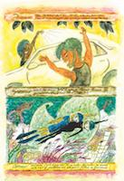 | Zeal Harris  Sandra Bland and El Chapo  Dye Sublimation on Fabric with  Glue and Beads  1/5 exclusive limited edition  25” x 16”, 2017 | $800
17. | 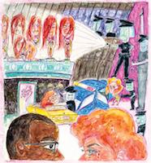 | Zeal Harris  Mind Meld  Dye Sublimation on Fabric  1/5 exclusive limited edition  22” x 20”, 2017 | $800
18. | 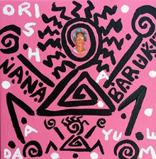 | Lili Bernard  Ayudame Nana Baruku  Acrylic on Canvas  8”x8”, 2017 | $500
19. | 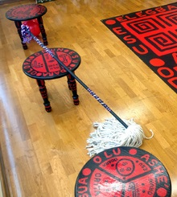 | Lili Bernard  Elegua Stool  Oil in canvas  24” x 19” | $1,200 each
20. | 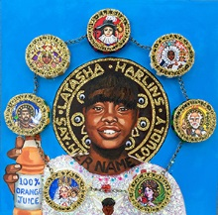 | Lili Bernard  Latasha Harlins en El Cielo con Las 7 Potencias Africanas  Oil Paint, Acrylic Paint, Metal Chain, Glitter, Plastic Eyeballs, Styrofoam, Plastic Angel, Faux Jewels  20” x 20”, 2017 | $3,300
21. | 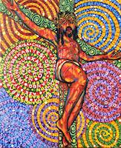 | Lili Bernard  Psychedelic Christ on the Cross  Oil on Canvas  24” x 19”, 2011 | $3,000
22. | 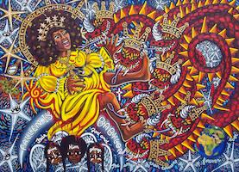 | Lili Bernard  Cachita-Ochun and the Dragon  Oil on Canvas  36” x 48”, 2011 | $7,000
23. | 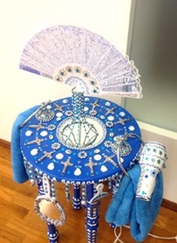 | Lili Bernard  Yemaya-Regla Altar-Hair Salon  Wood, Acrylic Paint, Faux Jewels, Cowries, Blow-Dryer, Afro-Pick, Comb, Towel, Metal, Mirrors, Fan, Peacock Feathers, Nail Polish, Glass Bottle, Pennies, Butterscotch Candy, Brass Bowl, Candle  36” X 26” X 26” | $5,000
24. | 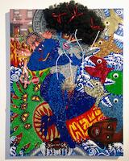 | Lili Bernard  Self-Portrait as Yemayá Under Attack  Sequin, Acrylic Paint, Afro Wig, Digital Photographs, Pipe Cleaners, Corks, Ribbons, Costume Jewelry, Glitter, Pills, False Eyelashes  48” x 36”, 2017 | $7,000
25. | 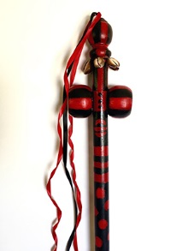 | Lili Bernard  Elegua Staff  Wood, Acrylic Paint, Cowry Shells, Ribbon, Twine  46” x 5” x 3” | $2000
26. | 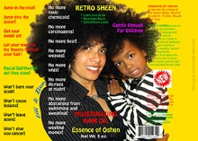 | Lili Bernard  Ochun-Caridad Retro Sheen Faux Advertisement, Archival Digital Print, limited edition of 10  30”x 39”, 2014 | $600
27. | 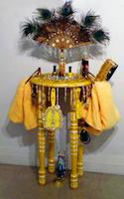 | Lili Bernard  Ochun-Caridad Altar-Hair Salon for Donning & Dismissal of the Conqueror’s Coiffure  Wood, Acrylic Paint, Costume Jewelry, Cowries, Blow-Dryer, Afro-Pick, Comb, Towel, Metal, Mirrors, Fan, Peacock Feathers, Nail Polish, Glass Bottle, Pennies, Butterscotch Candy, Brass Bowl, Candle  36” x 26” x 26”, 2014 | $5,000
28. | 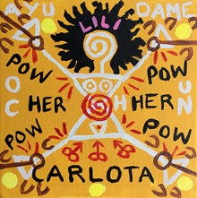 | Lili Bernard.  Ochun, Carlota y Lili  Acrylic on Canvas  6”x6”, 2017 | $400
29. | 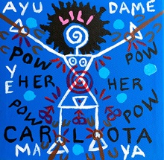 | Lili Bernard.  Yemayá, Carlota y Lili,  Acrylic on Canvas  6”x6”, 2017 | $400
30. | 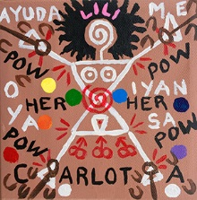 | Lili Bernard.  Oya-Yansa, Carlota y Lili  Acrylic on Canvas  6”x6”, 2017 | $400
BR. | 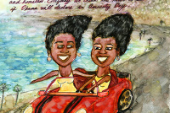 | Zeal Harris  Amnesty For Ngozi  Dye Sublimation on Fabric  2/5 exclusive limited edition  15” x 10”, 2017 | $400
BR. | 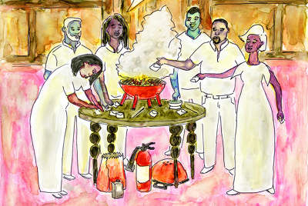 | Zeal Harris  Sanctified Hoodoo  Dye Sublimation on Fabric  2/5 exclusive limited edition  15” x 10”, 2017 | $400
BR. | 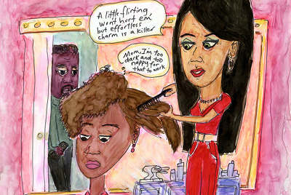 | Zeal Harris  Birds and Bees About Cops  Dye Sublimation on Fabric  2/5 exclusive limited edition  15” x 10”, 2017 | $400
BR. | 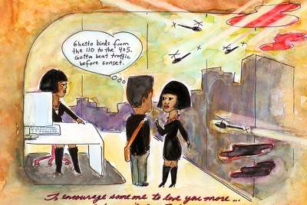 | Zeal Harris  Love Potion Against Ghetto Bird  Dye Sublimation on Fabric  2/5 exclusive limited edition  15” x 10”, 2017 | $400
BR. |  | Zeal Harris  Liturgical Language of a Free Traveler Studies  Mixed media on paper, 8” x 8” | $150 each  Inquire for whole set
BR. | 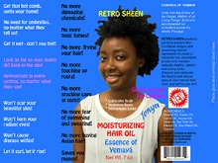 | Lili Bernard  Yemayá-Regla Retro Sheen Faux Advertisement, Archival Digital Print, limited edition of 10  30” x 39”, 2014 | $600
BR. |  | Zeal Harris  Limited edition giclées | $50

