 | 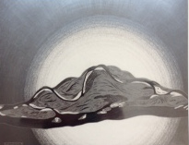 | Christine Weir  Fluctuation 7  Graphite on clay panel  11 x 14” |  | $800
2. | 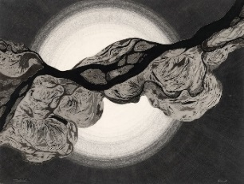 | Christine Weir  Uninvited Guests  Graphite on clay panel  18 x 24” |  | $1900
3. | 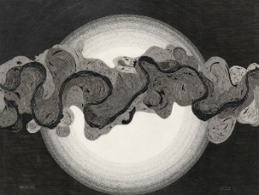 |  | Christine Weir  What I Now Know  Graphite on clay panel  24 x 36” | $3800
4. | 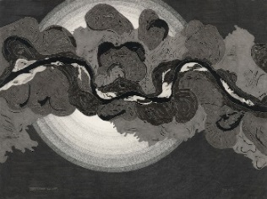 |  | Christine Weir  Their Currents Turn Awry  Graphite on clay panel  18 x 24” | $1900
5. | 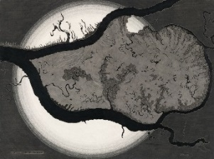 |  | Christine Weir  Yet Knowing How Way Leads On to Way  Graphite on clay panel  18 x 24” | $1900
6. | 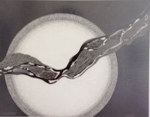 |  | Christine Weir  Fluctuation 6  Graphite on clay panel  11 x 14” | $800
7. | 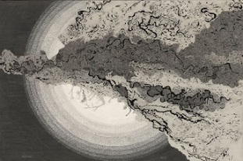 |  | Christine Weir  The Unraveling  Graphite on clay panel  24 x 38” | $3800
8. | 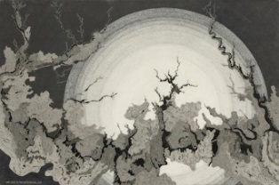 |  | Christine Weir  From Truth’s Sad Ashes Pain and Falsehood Grow  Graphite on clay panel  24 x 36” | $3800
9. | 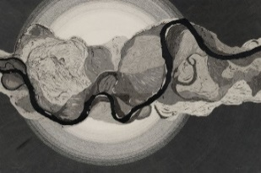 |  | Christine Weir  Palimpsest  Graphite on clay panel  18 x 24” | $1800
10. | 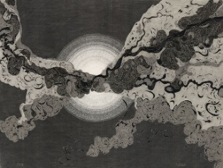 |  | Christine Weir  Crushed  Graphite on clay panel  18 x 24” | $1900
11. | 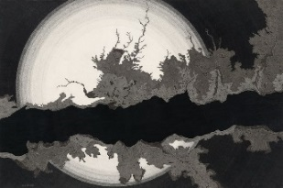 |  | Christine Weir  The Penitent  Graphite on clay panel  24 x 36” | $3800
12. | 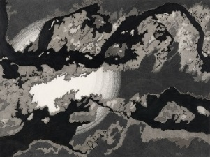 |  | Christine Weir  Decoherence  Graphite on clay panel1  18 x 24” | $1900
13. | 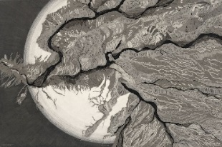 |  | Christine Weir  Having Had and Lost  Graphite on clay panel  24 x 36” | $3800
14. | 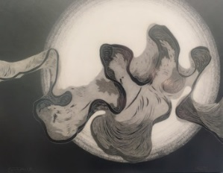 |  | Christine Weir  Fluctuation 3  Graphite on clay panel  11 x 14” | $800
15. | 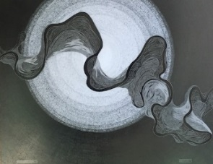 |  | Christine Weir  Fluctuation 4  Graphite on clay panel  11 x 14” | $800
16. | 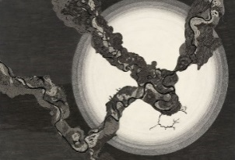 |  | Christine Weir  The Distancing  Graphite on clay panel  24 x 36” | $3800
17. | 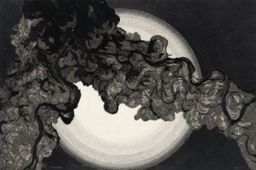 |  | Christine Weir  Thus to Ruminate  Graphite on clay panel  24 x 36” | $3800
18. | 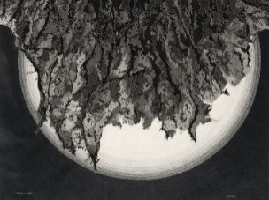 |  | Christine Weir  Escape is Done  Graphite on clay panel  18 x 24” | $1900
19. | 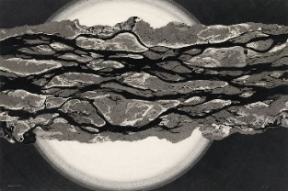 |  | Christine Weir  An Aporetic Crisis  Graphite on clay panel  24 x 36” | $3800
20. | 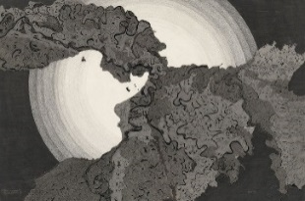 |  | Christine Weir  The Painful Eagerness of Unfed Hope  Graphite on clay panel  24 x 36” | $3800
BR | 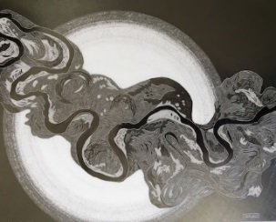 |  | Christine Weir  Fluctuation 5  Graphite on clay panel  11 x 14” | $800
BR |  |  | Christine Weir  The Return  Graphite on clay panel  24 x 36” | $3800

