1. |  |  | SANDY RODRIGUEZ  Western Ave  Oil on canvas  24” x 36” | $3,000
2. |  |  | SANDY RODRIGUEZ  Western Ave with Stars  Oil on canvas  16” x 20” | $1,800
3. |  |  | SANDY RODRIGUEZ  Night Vision 2  Oil on canvas  16” x 20” | $1,800
4. | 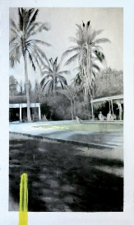 |  | KATRIN ASSMANN  Palm Trees with Pool  Oil on canvas  60” x 36” | $1,650
5. | 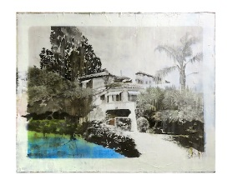 |  | KATRIN ASSMANN  California Mansion  Oil on canvas  60” x 72” | $2,500

6. | 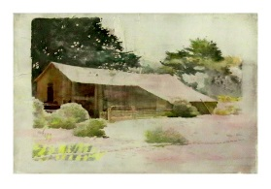 |  | KATRIN ASSMANN  California Barn  Oil on canvas  20” x 30” | $900
7. |  |  | KATRIN ASSMANN  Farmhouse Desert  Oil on canvas  20” x 30” | $825
8. |  |  | RYAN MOLENKAMP  Dead Horse Point 2  Acrylic on panel  36” x 48” | $2,600
9. |  |  | RYAN MOLENKAMP  Soufriere hills Volcano Montserrat (Fear of Volcanoes 94)  Acrylic on panel  24” x 30” | $1,075
10. |  |  | RYAN MOLENKAMP  Sound Cascade 18  Acrylic on panel  20” x 30” | $900
11. |  |  | RYAN MOLENKAMP  Fear of Volcanoes 91  Acrylic on panel  20” x 24” | $725
12. |  |  | EDWARD WALTON WILCOX  The Brilliant Dream  Bitumen and tempera on panel  18” x 24” | $4,600
13. |  |  | EDWARD WALTON WILCOX  Dawn in the Lowlands  Bitumen and tempera on panel  28” x 21” | $3,800
14. |  |  | EDWARD WALTON WILCOX  Though You Slay Me I Will Still Love You  Bitumen and tempera on panel  18” x 24” | $4,600
15. |  |  | EDWARD WALTON WILCOX  L.A. Dawn  Tempera and Bitumen on canvas  60” x 48” | $7,800

16. |  |  | EDWARD WALTON WILCOX  The Painted Tree  Oil and Bitumen on panel, handmade wooden shelf  6.5” x 15” | $2,500
17. |  |  | EDWARD WALTON WILCOX  The Most Perfect Day  Oil and Bitumen on panel, handmade wooden frame  17” x 18” | $4,000
18. |  |  | EDWARD WALTON WILCOX  The Secret I Keep in the Red River Grows  Bitumen and tempera on panel  20” x 30” | $5,800
19. |  |  | SANDY RODRIGUEZ  Rosslyn Million Dollar Fireproof Hotel  Oil on canvas  24” x 36” | $3,000
20. | SANDY RODRIGUEZ  Night Vision 2  Oil on canvas  16” x 20” |  | SANDY RODRIGUEZ  Mar Vista Dry Cleaners  Oil on canvas  8” x 8” | $600
21. |  |  | SANDY RODRIGUEZ  Mar Vista Luna  Oil on canvas  6” x 6” | $600
22. | 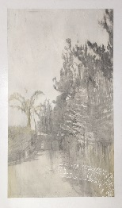 |  | KATRIN ASSMANN  The Path  Oil on canvas  69” x 36” | $1,850
23. |  |  | EDWARD WALTON WILCOX  Take My Heart My Kindred Spirit The Dawn is Coming  Oil and Bitumen on panel, handmade wooden shelf  19” tondo | $3,800
24. |  |  | RYAN MOLENKAMP  Double Arch  Acrylic on panel  18” x 24” | $650
25. |  |  | ERIC NASH  Mulholland Trance  Oil on canvas  48” x 72” | $10,000
26. | 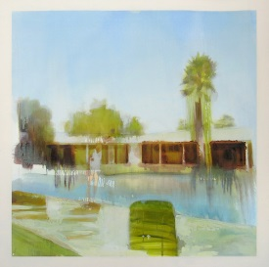 |  | KATRIN ASSMANN  Motel  Oil on canvas  48” x 48” | $1,800
27. | 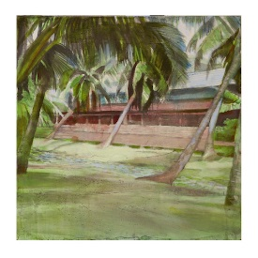 |  | KATRIN ASSMANN  Palm Trees  Oil on canvas  24” x 24” | $900
28. |  |  | RYAN MOLENKAMP  Sound Cascade 17  Acrylic on panel  20” x 30” | $900
29. |  |  | RYAN MOLENKAMP  Cliffs Near Capitol Gorge  Acrylic on panel  16” x 20” | $500
30. |  |  | RYAN MOLENKAMP  Fear of Volcanoes 97  Acrylic on panel  16” x 20” | $500

