1. | 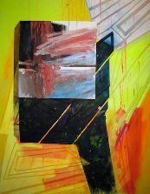 |  | JENNY HAGER  Sentinel  Acrylic on canvas  60” x 48” | $4,400
2. | 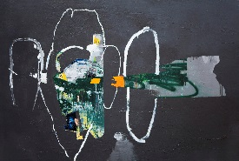 |  | TIM HUSSEY  Aphasia 2  Oil, acrylic, oil pastel, spray paint, collage on canvas  40” x 60” | $7,000
3. | 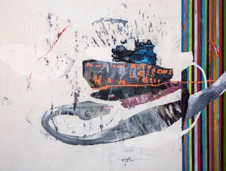 |  | TIM HUSSEY  Mary and Ruth Have Their Lessons  Oil, acrylic, oil pastel, charcoal on canvas  41” x 54” | $7,200
4. | 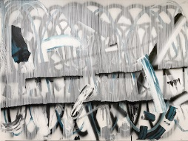 |  | NANO RUBIO  Street Signs  Acrylic on canvas  53” x 72” | $4,800
5. | 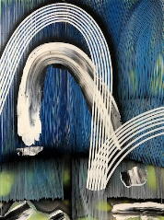 |  | NANO RUBIO  Unfolding the Stone  Acrylic on canvas  30” x 40” | $1,400
6. | 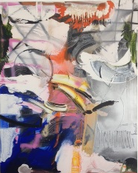 |  | PHILIPPA BLAIR  Alchemy  Mixed media on canvas  60” x 48” | $4,800

7. | 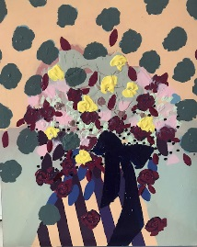 |  | ANA RODRIGUEZ  Untitled Gold  Oil and acrylic on canvas  20” x 16” | $675
8. | 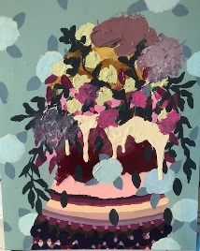 |  | ANA RODRIGUEZ  Untitled Green  Oil and acrylic on canvas  20” x 16” | $675
9. | 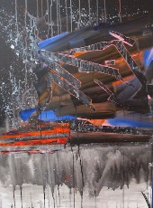 |  | JENNY HAGER  Kronos  Acrylic on canvas  40” x 30” | $1,400
10. | 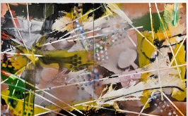 |  | PHILIPPA BLAIR  Pursuit Snow Leopard  Oil and spray paint on canvas  60” x 96” Diptych | $8,400
11. | 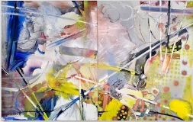 |  | PHILIPPA BLAIR  Alice In the Year of the Rabbit  Oil and spray paint on canvas  60” x 96” Diptych | $8,400
12. | 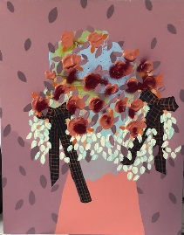 |  | ANA RODRIGUEZ  Untitled Fuchsia  Oil and acrylic on canvas  28” x 22” | $975
13. | 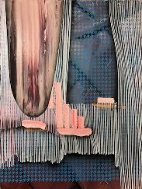 |  | NANO RUBIO  Dreaming While Awake  Acrylic on canvas  30” x 40” | $1,400
14. | 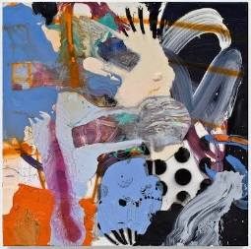 |  | PHILIPPA BLAIR  Cockatoo  Oil and spray paint on canvas  24” x 24” | $2,000
15. |  |  | CHRISTOPHER MERCIER  Mr Turners Ground  Mixed media on panel  11” x 14” x 13.5” x 6.5” | $2,500
16. | 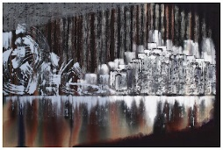 |  | BRYAN RICCI  Left Bank  Pigment and polymer on linen  48” x 72” | $6,000

17. | 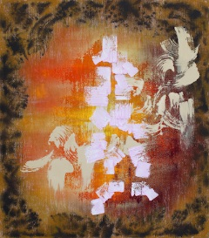 |  | BRYAN RICCI  View II  Pigment and polymer on linen  48” x 42” | $4,500
18. | 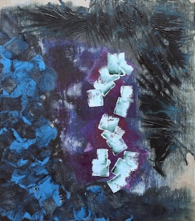 |  | BRYAN RICCI  Black Swan  Pigment and polymer on linen  41” x 36” | $3,800
19. | 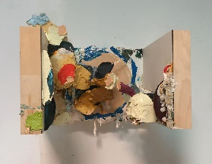 |  | CHRISTOPHER MERCIER  Wall Helmet 0215-16  Oil, ink, latex and enamel on  wood panel construction  11” x 18.5” x 14” | $3,000
20. | 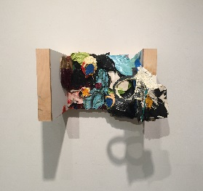 |  | CHRISTOPHER MERCIER  Wall Helmet 0015  Oil, ink, latex, and enamel on  wood panel construction  11” x 18.5” x 14” | $3,000
21. | 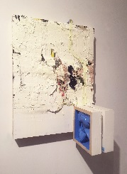 |  | CHRISTOPHER MERCIER  Squeeze Play  Miced media on panel  24” x 18” x 10.5” | $3,500
22. | 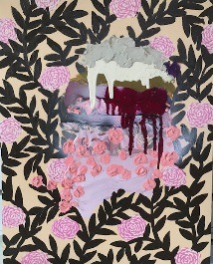 |  | ANA RODRIGUEZ  Untitled Pink  Oil and acrylic on canvas  20” x 16” | $675
23. | 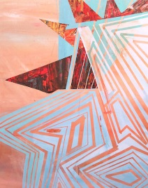 |  | JENNY HAGER  Raisonneur  Acrylic on canvas  60” x 48” | $4,500

