Contemporary Nostalgia – Danny Galieote / Antonio Pelayo
Antonio Pelayo
Untitled 8
Pencil on paper
28” x 22” framed
$1500.

.

 | 2. |  |  |  |  | Antonio Pelayo  Untitled 12  Pencil on paper  28” x 22” framed  $1500.  .
 | 3. |  |  |  |  | .  Antonio Pelayo  Untitled 11  Pencil on paper  28” x 22” framed  $1500.
 | 4. |  |  |  |  | . Antonio Pelayo  Untitled 4  Pencil on paper  28” x 22” framed  $1500.
 | 5. |  |  |  |  | Antonio Pelayo  Untitled 10  Pencil on paper  28” x 22” framed  $1500.
 | 6. |  |  |  |  | Danny Galieote  Taking Care of Business  Oil on canvas  31.5” x 46.5” framed  $8,400.
7. |  | 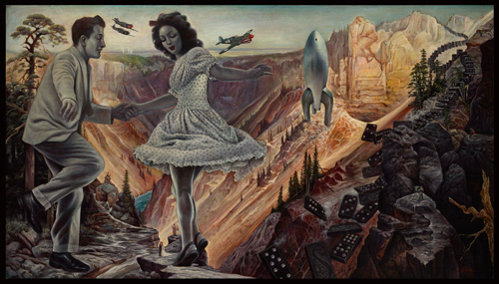 |  |  |  |  | Danny Galieote  American Anthem  Oil on canvas  43.5”x 76.5” framed  $14,900.
8. |  | 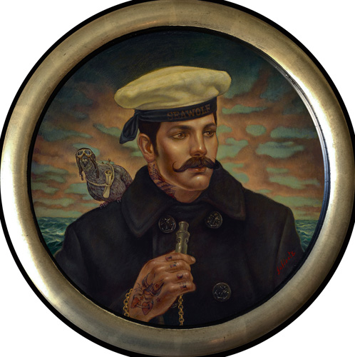 |  |  |  |  | Danny Galieote  The Messenger  Oil on canvas  19” round, framed  $3,200.
9. |  | 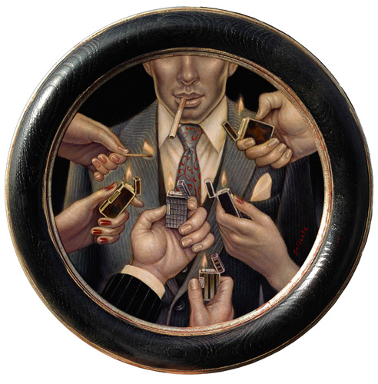 |  |  |  |  | Danny Galieote  The Most Interesting Man in the World  Oil on canvas  15” round, framed  $2,700.
10. |  | 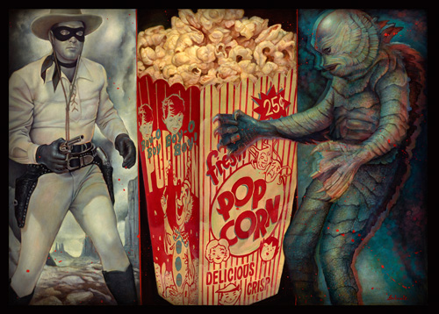 |  |  |  |  | Danny Galieote  Double Feature  Oil on canvas  45”x 63.5” framed  $14,900.
11. |  | 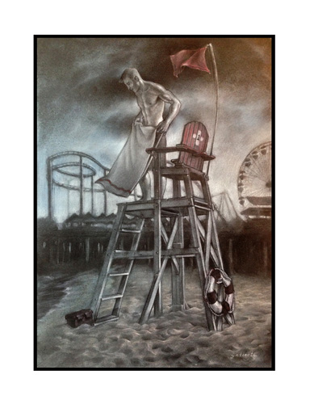 |  |  |  |  | Danny Galieote  Calling It A Day (study)  Charcoal / Pastel on Blue-Toned Fabriano Paper  24”x 19.5” framed  $1,500.
12. |  |  |  |  |  |  | . Antonio Pelayo  Untitled 10  Pencil on paper  28” x 22” framed  $1200.

13. |  |  | Antonio Pelayo  Untitled 6  Pencil on paper  22” x 28” framed  $1500.
14. |  |  | Antonio Pelayo  Untitled 7  Pencil on paper  28” x 22” framed  $1500.  $500
.  15. |  |  | Antonio Pelayo  Untitled 1  Pencil on paper  22” x 28” framed  $1500.
16. |  |  | Antonio Pelayo  Untitled 10  Pencil on paper  28” x 22” framed  $1500.
17. | 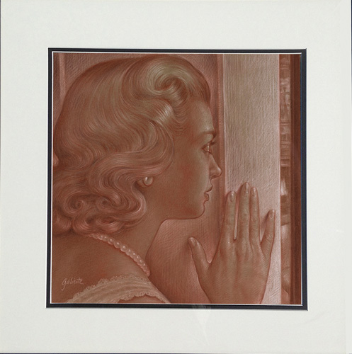 |  | Danny Galieote  The Visitor (study)  Charcoal and pastel on Fabriano paper  21” x 21” framed  $1,500.
18. | 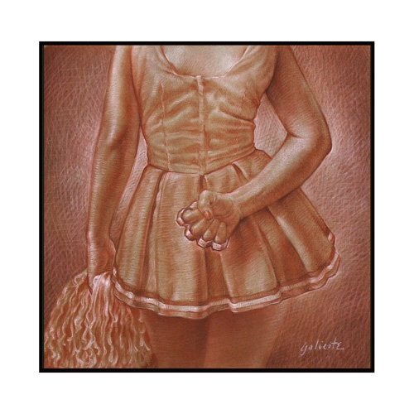 |  | Danny Galieote  Game On Bitch (study)  Charcoal and pastel on Fabriano paper  20 x 20” framed  $1,400.  .
19. | 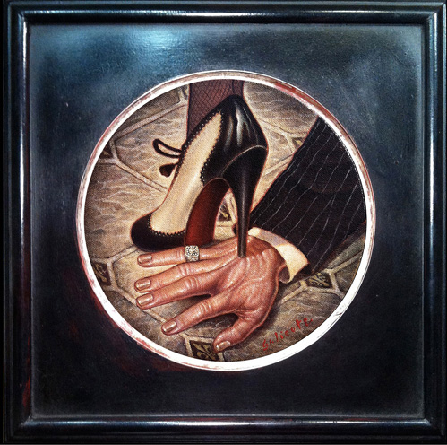 |  | Danny Galieote  Happy Wife, Happy Life  Oil on canvas  14” x 14” framed  $2,100.

20. | 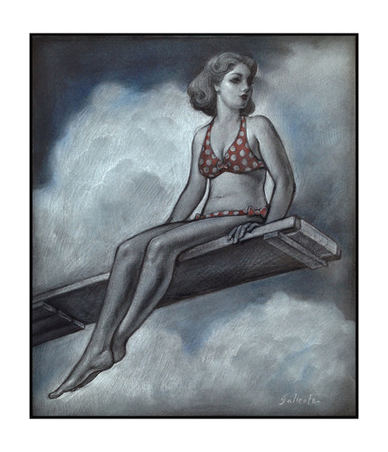 |  | Danny Galieote  High On Summertime (study)  Charcoal/pastel on blue-toned Fabriano paper  21.5” x 19.5” framed  $1,500.
21. |  |  | Antonio Pelayo  Untitled 9  Pencil on paper  22” x 28” framed  $1200.
BR.  BBR  BR. | 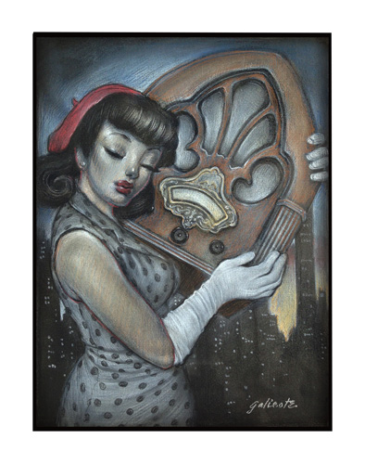 |  | Danny Galieote  Sweet Inamorata (Study)  Charcoal and pastel on Fabriano paper  19” x 17” framed  $1,400.
BR. | 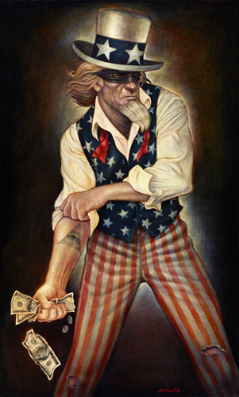 |  | Danny Galieote  Uncle Sham, Profit & Loss  Giclee print on canvas, (Edition of 75)  40” x 24”  $575.

