Ryan McCann – Random Acts of Fire
 |  |  | 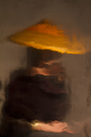 |  |  | She was taught at a young age to never let the  sun compromise her fair skin, 2016  Archival pigment print on hand-made rice paper  21” x 14” $900  28.5” x 21.5” $1100 framed  .
 | 2. |  |  |  |  | He came for the gold but stayed for the pussy, 2016  Archival pigment print on hand-made rice paper  21” x 14” $900  28.5” x 21.5” $1100 framed  Edition of 5  .
 | 3. |  |  |  |  | Potato Lady fights the cold, 2016  Archival pigment print on hand-made rice paper  21” x 14” $900  28.5” x 21.5” $1100 framed  Edition of 5
 | 4. |  | 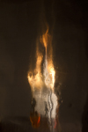 |  |  | . That was an epic night, part II, 2016  Archival pigment print on hand-made rice paper  21” x 14” $900  28.5” x 21.5” $1100 framed  Edition of 5
 | 5. |  |  |  |  | It was in the punk scene where he felt  most comfortable, 2016  Archival pigment print on hand-made rice paper  21” x 14” $ 900  28.5” x 21.5” $1100 framed  Edition of 5
 | 6. |  | 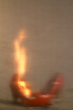 |  |  | After that night she never looked back, 2016  Archival pigment print on hand-made rice paper  21” x 14” $900  28.5” x 21.5” $1100 framed  Edition of 5
7. |  | 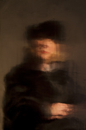 |  |  |  |  | She was so fucking rich, but that didn’t define  her, 2016  Archival pigment print on hand-made rice paper  21” x 14” $900  28.5” x 21.5” $1100 framed  Edition of 5
8. |  | 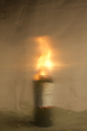 |  |  |  |  | He’s a wino tried and true, 2016  Archival pigment print on hand-made rice paper  21” x 14” $900  28.5” x 21.5” $1100 framed  Edition of 5
9. |  |  |  |  |  |  | Study for a screaming priest, 2016  Archival pigment print on hand-made rice paper  21” x 14” $900  28.5” x 21.5” $1100 framed  Edition of 5
10. |  |  |  |  |  |  | And suddenly all his problems disappeared, 2016  Archival pigment print on hand-made rice paper  21” x 14” $900  28.5” x 21.5” $1100 framed  Edition of 5
11. |  | 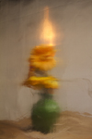 |  |  |  |  | And then he just left, 2016  Archival pigment print on hand-made rice paper  21” x 14” $900  28.5” x 21.5” $1100 framed  Edition of 5
 |  |  |  |  |  |  | .

12. | 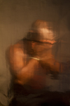 |  | The Truth, 2016  Archival pigment print on hand-made rice paper  21” x 14” $900  28.5” x 21.5” $1100 framed  Edition of 5
13. |  |  | She was Gaugin’s favorite, 2016  Archival pigment print on hand-made rice paper  21” x 14” $900  28.5” x 21.5” $1100 framed  Edition of 5
.  14. | 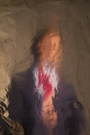 |  | As a politician he had to wear many faces, 2016  Archival pigment print on hand-made rice paper  21” x 14” $900  28.5” x 21.5” $1100 framed  Edition of 5
15. | 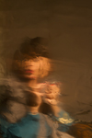 |  | It was her unlimited choice in men that gave  her confidence , 2016  Archival pigment print on hand-made rice paper  21” x 14” $900  28.5” x 21.5” $1100 framed  Edition of 5
BR. |  |  | She really took a lot of pride in dressing up, 2016  Archival pigment print on hand-made rice paper  21” x 14” $900  28.5” x 21.5” $1100 framed  Edition of 5
18. |  |  | Cole James  Bring In The Pawn, 2012  Tar, Rubber, Satin, Pearl Appliques, Acrylic & Glitter  Foam on Stretched Satin.  24” x 18”  $500.
BR. |  |  | Cole James  The Weight of My Fist, 2015  Satin, Acrylic, Paper, Lace on Quilted Satin,  Canvas  48” x 36”  $1300.

BR. |  |  | Ana Rodriguez  Untitled, 2015  Paper collage  21.5" x 17.5 " framed  $750.
BR. |  |  | Ana Rodriguez  Untitled, 2015  Paper collage  15.5" x 12.5 " framed  $750.
BR.  BBR  BR. |  |  | Ana Rodriguez  Untitled, 2014  Acrylic, oil on panel  24” x 18”  $950.
BR. |  |  | Ana Rodriguez  Untitled, 2012  Acrylic, oil on panel  24” x 18”  $650.
BR. |  |  | Cole James  Fly By Eves, 2014  Ink on vellum, framed  16" x 13"  $350.

