Quinton Bemiller - Clarity
 |  |  | 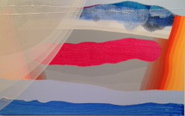 |  |  | Oasis, 2016  acrylic on canvas over panel  30 in. x 47 in.  $3800.  .
 | 2. |  | 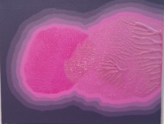 |  |  | Glow, 2016  acrylic on canvas over panel  11 in. x 14 in.  $800.  .
 | 3. |  | 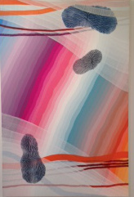 |  |  | Capricorn, 2016  acrylic on canvas over panel  47 in. x 30 in.  $3800.
 | 4. |  | 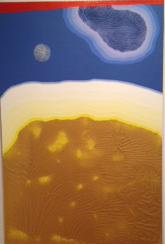 |  |  | Today is Tomorrow, 2016  acrylic on canvas over panel  36 in. x 24 in.  $2800.
 | 5. |  | 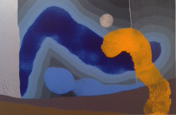 |  |  | Exploring the Night, 2016  acrylic on canvas over panel  24 in. x 36 in.  $2,800.
 | 6. |  | 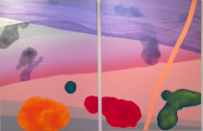 |  |  | Two Weeks Vacation, 2016  acrylic on canvas over panel  48 in. x 72 in.  $9,000.
7. |  | 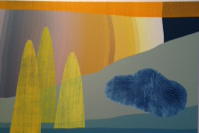 |  |  |  |  | Canyon Crest, 2016  acrylic on canvas over panel  24 in. x 36 in.  $2,800.
8. |  | 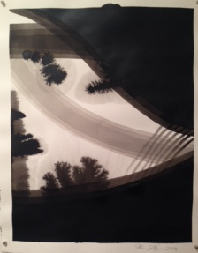 |  |  |  |  | Sail, 2016  India ink on Arches paper  20 in. x 16 in.  $800.
9. |  | 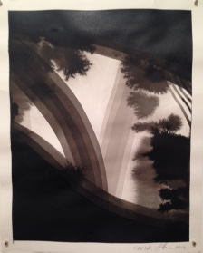 |  |  |  |  | Cascade, 2016  India ink on Arches paper  20 in. x 16 in.  $800.
10. |  | 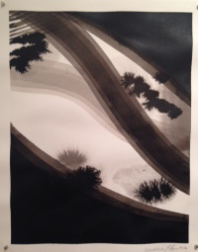 |  |  |  |  | Flourish, 2016  India ink on Arches paper  20 in. x 16 in.  $800.
11. |  | 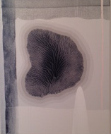 |  |  |  |  | Fog, 2016  acrylic on canvas  20 in. x 16 in.  $1,200.
12. |  | 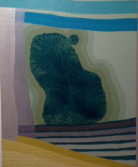 |  |  |  |  | Chaparral, 2016  acrylic on canvas  20 in. x 16 in.  $1,200.  .

13. | 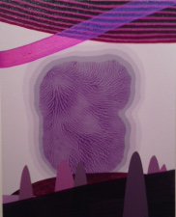 |  | Magic, 2016  acrylic on canvas  20 in. x 16 in.  $1,200.
14. | 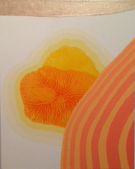 |  | Theia, 2016  acrylic on canvas  20 in. x 16 in.  $1,200.
.  15. | 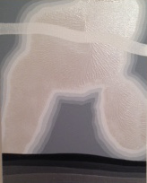 |  | Palladium, 2016  acrylic on canvas  20 in. x 16 in.  $1,200.  .
16. | 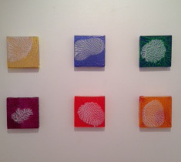 |  | Gold, Indigo, Green, Violet, Indigo, Red or Orange  Amuse - Bouche, 2016  acrylic on canvas over panel  6 in. x 6 in.  $250. each
17. | 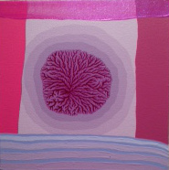 |  | Gateway, 2016  acrylic on canvas  12 in. x 12 in.  $800.
BR.

BR. |  |  | .
BR.

BR.

BBR

BR.
BR.
BR.
BR.

