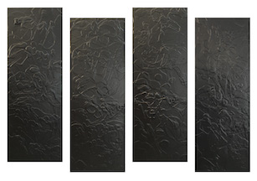  29. Home Town  40” x 56”  Latex and Acrylic on Panel  $5,800 | 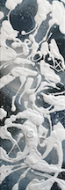  30. The Sea  36” x 12”  Latex, Acrylic and Spray Paint on Panel  $950
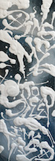  31. Sing Me To Sleep  36” x 12”  Latex, Acrylic and Spray Paint on Panel  $950 | 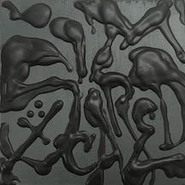  32. Scared  5” x 5”  Latex, Acrylic and Spray Paint on Panel  $175
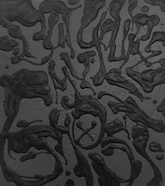  33. But You’re My Ghost  18” x 16”  Latex, Acrylic and Spray Paint on Panel  $650 | 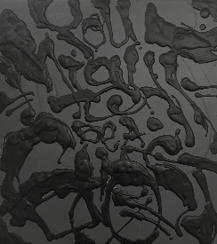  34. You Might Be A Ghost  18” x 16”  Latex, Acrylic and Spray Paint on Panel  $650
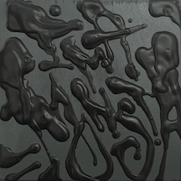  35. Monsta  5” x 5”  Latex, Acrylic and Spray Paint on Panel  $175 | 36. Go Outside  60” x 48”  Latex and Acrylic on Panel  $4,800
37. Enjoy the Silence  60” x 48”  Latex and Acrylic on Panel  $4,800 | 38. Shadows  60” x 48”  Latex and Acrylic on Panel  $4,800
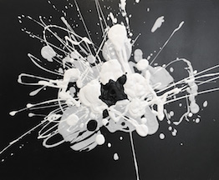  39. What’s In A Name Study 2  16” x 20”  Acrylic on Canvas  $600 | 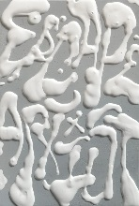  40. Escape Artist  7.5” x 5”  Acrylic and Spray Paint on Panel  $250
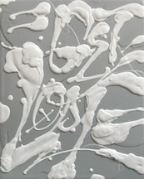  41. Get Lost  14” x 11”  Latex, Acrylic and Spray Paint on Panel  $475 | 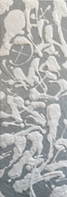  42. Spin Me A Tale  36” x 12”  Latex, Acrylic and Spray Paint on Panel  $950
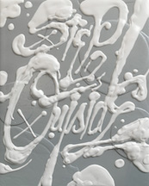  43. Step Outside  14” x 11”  Latex, Acrylic and Spray Paint on Panel  $475 | 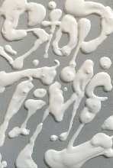  44. Stop Time  7.5” x 5”  Acrylic and Spray Paint on Panel  $250
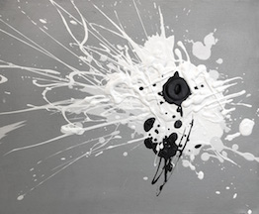
45. What’s In A Name Study 1
16” x 20”
Acrylic on Canvas
$600

