For immediate release

Bradford Salamon – Visages II

June 25 – July 23, 2016
OPENING RECEPTION: Saturday, June 25, 6-9pm
RSVP Required to: rsvp@launchla.org

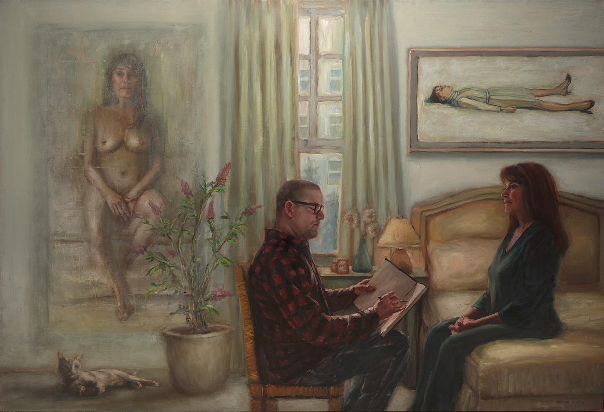
Launch LA is proud to present the latest solo exhibition from Bradford J. Salamon, Visages II.

A continuation of Salamon’s captivating portraits, Visages II showcases rich layering of paint combined with an intimately innate sense of the subject’s individuality. Maintaining a reverence for the past, influences range from Manet to Alice Neel, Lucien Freud, and Chuck Close, Salamon captures the essence, the spirit of the sitter in his manipulation of thick and calculated brushstrokes. There is a sense of liveliness and personal interaction with each of his subjects; art world contemporaries including critics, curators, and artists such as Mark Ryden and Twinka Thiebaud. Although portraits are one of the oldest traditions in the history of painting, Salamon maintains a fresh perspective, both through his subjects and facture. The sitter and the paint itself simultaneously become subjects of the portraits.

Conversation with his subjects while sketching or painting is the key to their authenticity – the spark that ignites the liveliness of the portrait. Affected by the varying emotions of the sitter, Salamon venerates the subtle energies of each subject, crafting a master narrative within each pictorial frame.

In his truthful, candid representations, Salamon demonstrates a mastery of the painterly medium and an intense examination and love of the human form, rendering every curve, fold and contour with evocative force.

“I paint portraits to create a journal of my life but also to document time and how time changes us and our relationships; sometimes for the better and sometimes for the worse. I try to paint what it’s like to be alive.” – Bradford Salamon

For More Information, contact James Panozzo, james@launchla.org
Press contact: Andrea Newell, andrea@launchla.org

