For immediate release

Hung Viet Nguyen – Sacred Landscape II
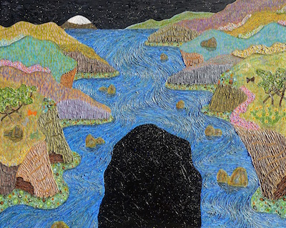
July 30 – August 27, 2016
OPENING RECEPTION: Saturday, July 30, 6-9pm
RSVP Required to: rsvp@launchla.org

Launch La is proud to present Sacred Landscape II, the latest exhibition from Hung Viet Nguyen featuring two new series of paintings.

SACRED LANDSCAPE II Series (2015-present)
Continued from the 2014-201 series SACRED LANDSCAPE, this new body of work searches further to discover new forms, colors and spaces. Each painting expresses a unique perspective of scenery, distance, and space as a kaleidoscope of foreground, middle, and background.
PERSONAGE Series (2015-present)
This new series of paintings express whimsical landscapes through swirling layers of paint and meticulous fields of bold colors. Playfulness with shapes and forms provide an inlet into the artist’s imagination through natural elements.
The salty scent of crashing waves, shear canyons and cliffs rise and drop in perspective, with colors that only exists in the bright Southern California sun...these along with the floating clouds and stars in the night sky are the inspirations that guide Hung Viet Nguyen. Each painting is a visual expression of the senses rather than a literary representation of a landmark; the emotion and spirit of each gathered from hikes in different regions around the globe and translated into a semi-abstract expression of what it felt like to be there.
Nguyen accomplishes this with complex layering of paints. Starting with thick bases of oil under-painting, Nguyen organizes space into landmass, sky, and water boundaries. The body of the painting appears with the addition of the expressionist, swirling grooves. Adding paint and scraping it away builds the texture and reveals the hidden layers of color beneath. Painting in oil is a time consuming process, which takes weeks to accomplish, but allows the ability to work in boundless layers. Working on several paintings simultaneously, all finish seemingly, at once. Once the textures are dry, applied glazes achieve the final envisioned color.
Aside from a semi recognizable landscape, Nguyen experiments with forms and shapes to create sensual landscapes that exude a uniquely mosaic quality. Capturing the spirit and emotion of each imagined space, it is certain that nature is a sacred place.
- - -
Artist Hung Viet Nguyen was born in Vietnam in 1957. He studied Biology at Science University in Saigon, Vietnam, then transitioned to working as an illustrator, graphic artist and designer since settlement in the U.S. in 1982. He developed his artistry skills independently, studying many traditional Eastern and Western forms, media and techniques. Nguyen’s complex, labor intensive investigations of oil paint reveal a methodical mastery of texture.
Hung Viet Nguyen has exhibited art works at Art Fairs: ART CONTEXT NEW YORK, PALM BEACH ART MIAMI, LOS ANGELES CONTEMPORARY ART, PALM SPRINGS FINE ART, FABRIK EXPO LOS ANGELES (2016 Art Fairs). SPECTRUM MIAMI ART SHOW, ART SILICON-SAN FRANCISCO, HOUSTON FINE ART FAIR, ART SAN DIEGO, WestEDGE DESIGN FAIR-SANTA MONICA (2015 Art Fairs).
Honors include the Juror’s Choice Awards, 2013, and the San Diego Art Institute Biennial International Award Exhibition, 2015.

For More Information, contact James Panozzo, james@launchla.org
Press contact: Andrea Newell, andrea@launchla.org

