For immediate release
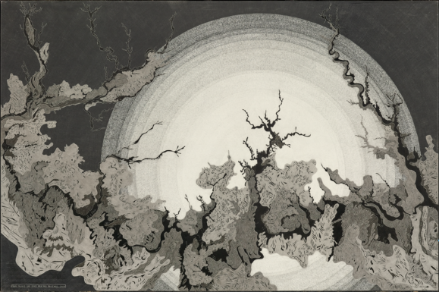
Christine Weir – Qualia
May 20th – June 17th, 2017
OPENING RECEPTION: Saturday, May 20th, 6 - 9pm
RSVP Essential to: rsvp@launchla.org
Gallery Hours: Wednesday – Saturday 12-6pm

Launch LA is proud to announce its upcoming exhibition with local artist Christine Weir. Qualia is a survey of Weir’s latest body of work that explores the emotional complexities of contemporary life. In this series, she meticulously and earnestly chronicles the internal response to chaos brought upon us through outside circumstances.

Her most personal body of work to date, Weir uses drawing to take control and have power over this chaos. Each piece is an intricately detailed work of graphite on clay panel with flowing forms reminiscent of flowing rivers. The stark contrast and subtle details builds tension through shadows of light and dark and countless hours spent softly layering different weights of graphite. Each mark, location, and shape holds a different meaning for each onlooker, strenuously leading us across the panel through riverlike and mountainous forms.

Glowing, circular forms give us consistency and space to reconnect with our singular selves. These are a break from the tumultuous and controlled pandemonium that encompasses us on a daily basis through all-consuming commitments – relationships or otherwise. Weir’s forms draw from physical and emotional scars etched onto the landscapes of our lives and the geography that we inhabit. By chronicling this trauma in black and white, Weir’s pieces become objective windows through which we can continue to examine the anxieties and emotions of our lives.

About Christine Weir
After graduating with a BFA in fine arts and drawing from the University of Kutztown, Christine Weir moved to New York City to pursue an MS in Art History at Pratt Institute. She began working as an art appraiser at an auction house in Los Angeles where she experienced a constant influx of artworks, handling thousands of pieces a year. Her interactions with the pieces began to inspire her, paying close attention to alternative techniques and processes while becoming more in tune with what made successful compositions and how she related to the creative process.

