For immediate release

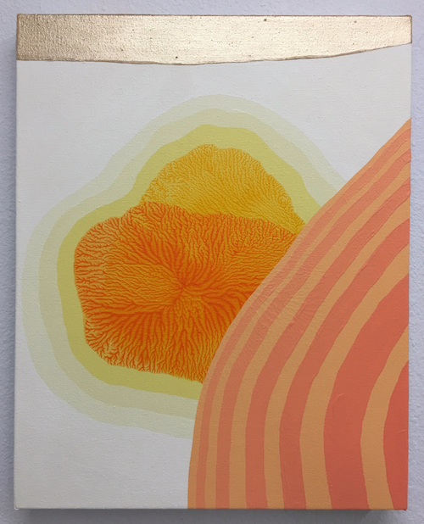
Quinton Bemiller – Clarity

April 9 – May 7, 2016
OPENING RECEPTION: Saturday, April 9, 6-9pm
RSVP Required to: rsvp@launchla.org

On the surface, Bemiller’s paintings are imagined spaces with a reference to natural environments. Yet within these paintings, pulsating applications of color exude a deeply lucid yet esoteric connection to our surroundings, spanning both place and time. The title of this exhibition, Clarity, refers to making tangible the intangible. Observing your physical surroundings, the mental and emotional connections felt, and translating those sensations into a visual medium. Clarity is the ability to see these invisible moments where the physical and metaphysical aspects of lived experience converge.
Investigating not only the formal properties of the works through the undulating luminosity of color fields, transitions and sequences, the subtle shifts in color also relate to temporal processes in the world, such as life cycles of plants, animals and people, changes in the environment and various types of energy forces. Works like Canyon Crest, reflect the cyclical rising and setting of the sun over rolling hills, while other works like Theia reference both a physical ancient planetary mass in the Solar System and the mythological Titaness, Theia, the mother of Selene the goddess of the moon, in which the painting echoes the planet Theia's collision with the early Earth and the subsequent creation of the Moon.
These works do not simply document or imitate color changes in nature, but capture the overall effect of our emotions and states of mind. In other words, a view into the reality of our mind, as opposed to the reality of things.
There is a type of alternative reality in Bemiller’s paintings, a consistent logic that keeps everything in order but yet is not specifically connected to our physical world.
“For me, making a painting is something of a meditation. Painting brings about a greater state of awareness and clarity within me. I hope that people who view my paintings will share this state of mind. My intention is to let the experience of making paintings reflect my experiences in life and that others will see my paintings as an experience through which they may reflect on their own life.”
- - -
BIOGRAPHY

“Quinton Bemiller is an industrious artist whose work with process and color documents a disciplined practice. For the most part, Bemiller’s acrylic paintings evoke an obsession with beauty and fantasy rather than with the existential reality that preoccupied abstract expressionists...”
--Mary Anna Pomonis, THE Magazine, 2009

Quinton Bemiller was born in Arcadia, California in 1976. He received an M.F.A. from Claremont Graduate University, a B.F.A. with high honors from College of Art and Design at Lesley University (formerly The Art Institute of Boston) and an A.A. from Pasadena City College. He has exhibited locally and nationally at institutions such as 808 Gallery, Boston University; Plant Zero Art Center, Richmond, Virginia; Torrance Art Museum; Fullerton Museum of Art, Cal State San Bernardino University; Kellogg Art Gallery, Cal Poly Pomona University; Los Angeles Municipal Art Gallery; Armory Center for the Arts; Laguna Art Museum; Los Angeles International Airport; Pacific Design Center; Arena 1, Santa Monica, CA and Offramp Gallery, Pasadena, CA. Bemiller is the recipient of Individual Artist Grants from both the City of Los Angeles and the City of Pasadena, CA. His work can be found in the permanent collection of the Boston Public Library and numerous private collections. The artist lives and works in Riverside, CA and is a tenure-track Assistant Professor of Art and Director of the College Art Gallery at Norco College, Riverside Community College District.

